William and Samuel Molyneux: The Astronomers of Castle Dillon Armagh. By J.A. Finnegan.
This paper describes the distinguished lives and accomplishments of William Molyneux FRS and those of his son, Samuel Molyneux FRS: Courtier, Politician, Astronomer and telescope maker.
With substantial estates in Ireland, Samuel Molyneux (1689–1728) came from a wealthy background. Graduating from Trinity College Dublin, he spent the years 1710-1712 on the improvement of the estate at Armagh, utilising a library and Observatory at Castle Dillon created by his late father William Molyneux FRS (1656-1698) The distinguished polymath and Member of Parliament for Trinity College Dublin. In 1697 William offered to underwrite the second edition of the Philosophiae Naturalis Principia Mathematica for Isaac Newton and has been called “perhaps the single most important figure in the history of Irish Science” (Section 1.2).
Visiting London, on 1st December 1712 and proposed by Newton, Samuel Molyneux was elected Fellow of The Royal Society and “receiv`d by…men of distinguish`d character”. He continued to reinforce and progress his family`s connections at Court and with the most influential intellectual and political figures of this era; as vividly described in his letters to his uncle, Dr. Thomas Molyneux FRS (1661-1733) (Section 2). Subsequently, in 1714 King George I appointed Samuel Molyneux Principal Secretary to his son Georg August, the new Prince of Wales (Section 3).
In 1721, “[Samuel] Molyneux has a mind to purchase the Mural Arc, and the quadrant that used to stand in the great room” at Greenwich Observatory (Section 4.1). In 1725, using Samuel`s private observatory at Kew House London, Samuel Molyneux and Rev. James Bradley FRS (1692-1762) commenced precise positional measurements of Gamma Draconis, initiating what have been called “the great discoveries, the Aberration of Light and the Nutation of the Earth’s Axis”. Bradley wrote, “But if it [Molyneux`s “Parallax instrument”] had not greatly exceeded the Doctor's [Hooke] in Exactness, we might yet have remained in great Uncertainty as to the Parallax [distance] of the fixt Stars” (Sections 4-7). In 1727, Samuel`s invitation to Dr. Robert Smith FRS (1689-1768) Plumian professor of astronomy at Cambridge, to become resident at his observatory at Kew, suggests Samuel’s intention of continuing observations using complementary parallax instruments (Sec. 6).
The circumstances and consequences of Samuel`s bizarre death in 1728 at the age of just 38, which prevented his plans being implemented, are detailed (Section 8-9). Samuel Molyneux was an authority on the casting of “Metalline Specula” (Section 4.0). Listed in the posthumous 1730 Kew House Observatory auction catalogue (Section 9) “A large Concave Metalline Speculum, 26 Inches Diameter, fitted with proper Apparatus to set it in different Positions, made by Mr Molyneux" appears to describe what would have been the world’s largest telescope (Section 10).

Contents:
1. The Molyneux Family.
1.1. The Molyneux family were a long-established part of the Protestant Anglo-Irish ruling class of Ireland, with substantial estates at Castle Dillon Armagh, Kildare and Limerick.
1.2. William Molyneux FRS. 1656-1698. `Sciothericum Telescopium`, `Dioptrica Nova` and `The case of Ireland`s… stated`.
1.3. Samuel Molyneux FRS. 1689-1728. Astronomer, Courtier and Politician.
2. “Receiv`d by…men of distinguish`d character”. Samuel Molyneux`s visit to England, October 1712 to April 1713.
2.1 Illustrative examples of people and places visited and described by Samuel Molyneux.
3. Appointment to Court of King George I.
3.1. Samuel Molyneux. Council of The Royal Society. Marriage and inheritance.
4. Astronomy and optics. Cooperation and experimentation.
4.1. The Annual Stellar Parallax question. How far away are the stars?
4.2. Samuel Molyneux`s preliminary research and response to the Annual Stellar Parallax question.
5. Parallax instrument at Kew House.
5.1. Parallax observations and measurements from Kew House begin. “a certain nutation in the earth” which apparently “destroyed entirely the Newtonian system”.
5.2. A yearly cycle of contrary stellar positional displacement.
5.3. Observations and measurements from Kew continue. Contrary positional patterns. A more sophisticated explanation, `a new discovered motion`.
6. The `Parallactik sector` at Wanstead. Two instruments “and we go on comparing note”.
6.1. Observations and measurements from Wanstead commence. Relative velocities and the distance of the Stars. `A new law of nature`.
7. The `Aberration of light` phenomenon. `Speed of light` and the Earth`s movement in space.
7.1. `Nutation of the Earth's axis`. James Bradley`s appointment as the 3rd Astronomer Royal.
7.2. Accolades and publication of the Kew and Wanstead observations.
8. The suspicious death of Samuel Molyneux.
8.1. The bizarre case of Lady Elizabeth Molyneux and Nathanael St Andre.
8.2. Samuel Molyneux; achievements and legacy.
9. Samuel Molyneux`s library and instruments. Fate of the Kew `Parallactick telescope`.
9.1. Samuel’s good friend, the second Astronomer Royal Dr Edmond Halley, appears to have bought a number of significant items.
10. Folio 61. Item 51. “A large Concave Metalline Speculum, 26 Inches Diameter, fitted with proper Apparatus to set it in different Positions, made by Mr. Molyneux".
If this description is not mistaken…. it states that Samuel Molyneux had made the major component part of what could then have been the world`s largest telescope.
11. Kew House and Castle Dillon after Samuel Molyneux`s death.
In May 1730, Kew House was leased to the son of King George II, Frederick Prince of Wales and became the residence of his wife Augusta Princess of Wales, the mother of King George III.
- The Molyneux Family.
1.1. The Molyneux family were a long-established part of the Protestant Anglo-Irish ruling class of Ireland, with substantial estates in Armagh, Kildare and Limerick. First recorded in the English community in Calais in 1530, they settled at Swords in Ireland about 1576. In 1596, their ancestor Sir Thomas Molyneux (1531-1599) Chancellor of the Exchequer of Ireland to Queen Elizabeth I, was a major founding benefactor of Trinity College Dublin. His third son, Daniel Molyneux (1568-1632) was Ulster King of Arms. His son, William Molyneux`s father Captain Samuel Molyneux (1616-1693) although trained in law, was Master Gunner of Ireland in the Cromwellian period. Rewarded for his services, in 1664 he bought the 6,009-acre Castle Dillon estate at Armagh for a total of £3,444.
1.2. William Molyneux FRS. (Fig. 2) `Sciothericum Telescopium`, `Dioptrica Nova` and `The case of Ireland`s… stated`.
Educated privately and at St Patrick`s Cathedral school Dublin, on the 10th April 1671 the 15 year old William Molyneux entered Trinity College Dublin. He said, “I could never approve of that Verbose Philosophy there professed and taught” and instead became a studious reader of the Philosophical Transactions of the Royal Society and figures of the scientific enlightenment such as Descartes, Bacon and Gassendi. He graduated Bachelor of Arts in 1674, described as having “excellent natural character and great probity of manners” and was sent by his father to study law at the Middle Temple London from 1675 to 1678. Married in September 1678, in 1679 and 1680 he diligently sought a cure in England for his recently blind wife, Lucy, and published his translation from Latin of Descartes` Six Metaphysical Meditations. Tellingly, William Molyneux`s Preface compares the Six Meditations to the “six days work of the Supream Architect” and that “the Restauration of Truth out of Error is the most Divine Work”. Dedicated to his “honoured and affectionate father” William also translated from Latin and Italian, Galileo Galilei's (1564-1642) final book, `Discorsi e Dimostrazioni Matematiche Intorno a Due Nuove Scienze`, published at Leiden by Lodewijk Elzevir in 1638.
In September 1681, William Molyneux initiated a productive ten-year collaboration with King Charles II`s first ‘Astronomical Observator’, the Rev. Dr John Flamsteed FRS (1646−1719). On the 29th May 1682 in a letter to William Molyneux, Flamsteed said that he had learnt most about optics from “some loose [unpublished] papers of Mr Gascoigne, an ingenuous young gentleman who was slaien at York fight…and all I know of glasses is but a superstructure of that foundation”.
Using a two-foot quadrant with “telescopicall sights” built by John Browne and tested by Flamsteed, William attempted to observe from Dublin the comet of August 1682, later known as Halley`s comet. He also owned telescopes with object glasses made by London optical instrument maker John Yarwell, “exactly ground on brass tools….approved by the Royal Society”, of 8, 12, 16 and 30 feet focal lengths, observing and measuring the Lunar and Solar eclipses of 1681-86. Encouraged by his younger brother Thomas Molyneux (1661-1733) then studying medicine at Leiden, and following the exemplar of the Royal Society, in October 1683 William became the first Secretary and joint founder of what later became the Dublin Philosophical Society, corresponding with Edmond Halley (1656-1741) and Johannes Hevelius (1611-1687) regarding the advantages of “telescope sights above plaine ones”.
After a collaboration in a Royal Society cartography project with Moses Pitt (1639-1687) in 1684 William Molyneux, jointly with Sir William Robinson (1645-1712) was appointed as Chief Engineer and Surveyor General of the King`s Buildings and Works in Ireland. In this role, commencing June 1685, William and Thomas Molyneux spent three months touring Flanders, Holland, France and Germany. With letters of recommendation from Flamsteed, they visited astronomer Jean Dominique Cassini at The Paris Observatory, mathematician and physicist Christiaan Huygens at The Hague and microscopist Van Leeuwenhoek in Delft. In Paris, “Mons. Borelly”, gifted William a twenty-four feet focal length object glass.
On 5th September 1685, having returned to London, William was invited by Flamsteed to visit him at Greenwich Observatory to discuss his travels. Flamsteed wrote, “if your occasions will permit you to make a little voyage to Greenwich and stay a night or two with me. You will find clean linen, slender fare, and hearty welcome…if you bring no company besides your servant our conversation will be the freer”. Ill-advisedly, Edmond Halley accompanied William Molyneux, causing Flamsteed to state, “I plainly told him before he trust himself upon you as a companion hither that I would make no provision for him”. Previously, in 1675, the 19-year-old Halley had assisted Flamsteed, who referred to him as “a brilliant young man of Oxford”. Since Halley queried the age of the Earth and the story of creation as given in the Bible, Flamsteed now thought, “they are an odd sort of people that are not to be esteemed Christians, and a modest heathen would be ashamed of their way. That creed is theirs which serves their interest best, and such cattle are dangerous”.
In 1686, William Molyneux was elected Fellow of The Royal Society and published `Sciothericum Telescopium`. This described his dual telescopic “dial”, made for him by Richard Whitehead, “a Mathematick Instrument Maker” of London and able to “determine the time of day or night to 3, 5, or 7 seconds… without any calculation of triangles”. It included, for the first time in English, the Equation of Time figures derived by Flamsteed. The Sciothericum instrument, “very large and curiously wrought” (Fig.12) was presented to the new Lord Lieutenant of Ireland, Henry Earl of Clarendon. A devout Anglican and brother-in-Law of the Catholic King James II. In 1703 a Sciothericum Telescopium was catalogued as in the collection of Trinity College Cambridge.
On 4th April 1687, having just received from Issac Newton the manuscript of Book III of the `Philosophiae Naturalis Principia Mathematica`, William`s friend and colleague Dr Edmond Halley, “head-clerk or under-secretary to the Royal Society”, sent to him in Dublin via Thomas Molyneux before its publication, “several parts of this inestimable treasure as they came from the press”. Halley assured William that he looked upon it “as the utmost effort of human genius". William Molyneux was “struck with the same astonishment as the rest of the world” and stated modestly that “he was not qualified to examine the particulars”. In May 1687, in correspondence with Flamsteed, William Molyneux said of the `Principia`, “tis incomparable….it is a piece that requires great application, or else it is invincible”. On 5th July 1687, Halley wrote to Newton, confirming that the printing of the book`s 511 pages was finally complete and sent him forty copies.
In January 1689, William Molyneux, his blind wife Lucy and his younger brother, Thomas, fled from Dublin to Chester, fearing political difficulties and religious persecution during the deposition of the Catholic King James II. They remained in Chester for two years, returning in January 1691 to William`s parents’ home near Ormond Gate in Dublin after King James II was defeated at the Battle of the Boyne in July 1690 by his son in law, the new Protestant King William III.
In 1692, dedicated `To The Illustrious The Royal Society`, William Molyneux published `Dioptrica Nova`, the first optical treatise to be published in English, antedating Huygens' Dioptrica and Newton's Opticks. William stated, “I am sure there are many ingenious Heads, great Geometers, and masters in Mathematics, who are not so well skill`d in Latin”. It was favourably reviewed by Huygens and Leibniz referred to it as “a very excellent book”. Personal copies were gifted by Molyneux to Newton, Flamsteed and Halley. In 1709, the Irish philosopher, empiricist and mathematician George Berkeley (1685-1753) utilised it for his `An Essay Towards a New Theory of Vision`, which examined in detail the psychology of visual perception.
In late 1692, William`s dying father “handed over” to him the management of the Castle Dillon estate at Armagh. He died on the 23rd January 1692/3, aged seventy-six. William wrote, “he was hardly quiet in his grave, when I thought I should follow him thither… seized with a violent colick…brought me very weak”. The Armagh estate now required William`s considerable attention, as the Protestant tenants had been driven out during the reign of King James II and new leases had to be negotiated. Awarded M.A. in 1692 and LL.D in 1693, William was Member of Parliament for Trinity College Dublin in 1692 and 1695 to 1698. Previously, he had commenced writing a “Mathematical Dictionary”, the unfinished manuscript selling at auction in 1730.
On 4th November 1697, anticipating a second edition of the `Principia`, William Molyneux wrote to the Royal Society Secretary, Dr Hans Sloane FRS, asking him to recommend to Newton, “to make it a little more plain to readers not so well versed in abstruse mathematiks; a few marginal notes and references and quotations would doe the business”. Molyneux also offered to underwrite the second edition for Newton, who had been appointed Warden of the Royal Mint in 1696. After William Molyneux`s death in 1698, Roger Cotes FRS (1682-1716) first Plumian Professor of Astronomy at Cambridge, assisted and supervised the second edition from 1709 until its publication in July 1713.
In 1698, dedicated to King William III, William Molyneux published `The Case of Ireland`s Being Bound by Acts of Parliament in England, Stated`. Molyneux wrote, “For `tis the cause of the whole race of Adam that I argue: liberty seems to be the inherent right of all mankind”. Jonathan Swift FRS thought that “it ought to be written in letters of Gold” and in `Drapier`s Fourth Letter` Swift said, “Indeed the arguments on both sides were invincible… For in reason all government without the consent of the governed is slavery, but in fact eleven men well-armed will certainly subdue one man in his shirt”. In April 1770, a copy of the 1770 edition was sent by Benjamin Franklin FRS from London to Boston, where it “had an impact on American ideas of independence”. Samuel Adams, a signatory to the American Declaration of Independence, referred favourably to the book and later editions were in the libraries of President`s Thomas Jefferson and James Madison. In 2003, P. Wayman and N.D. McMillan wrote, “William Molyneux was perhaps the single most important figure in the history of Irish Science, and one of great political significance”.
1.3. Samuel Molyneux FRS. Astronomer, Courtier and Politician. (Fig. 1)
Samuel Molyneux was born in Chester on the 18th July 1689, the third and only surviving child, of William and Lucy Molyneux. Lucy was the youngest daughter of Sir William Domville, the Attorney General for Ireland, and died aged thirty on the 9th May 1691 when Samuel was still not two years old. In March 1693, William wrote to his good friend, the philosopher and physician John Locke (1632-1704) “I have but one child in the world…nigh four years old…so that my whole study shall be to lay up a treasure of knowledge in his mind for his happiness both in this life and the next…I have been often thinking of some method for his instruction that may best obtain the end I propose…to my great joy, I hope to be abundantly supplied by your method”.
`The ingenious Molyneux` actively undertook Samuels’s education on the principles described in Locke`s `Some Thoughts Concerning Education` but “because he is come from a tender and sickly mother” some of Locke`s stricter rules were not applied. In 1694, a private tutor was appointed for Samuel and it was proposed that he should also learn a trade and be taught shorthand, “as useful a knack as a man of business or any scholar can be master of”. William wrote to Locke, “to tell you of extraordinary effects your method of education has had on my little boy” and that the five year old Samuel was now “of a most towardly and promising disposition, bred exactly, as far as his age permits, to the rules…. and was able to read very well and could point out all the noted parts, countries, and cities of the world”. At five and a half years old, Samuel had “been 3 months at Latin” and “could understand latitude and longitude, differences of time and the antipodes. In August 1695, William wrote to Locke that the six year old Samuel “could manage a compass, ruler, and pencil very prettily and perform many geometrical tricks….was obedient and observant to the nicest particular, and at the same time sprightly, playful and active”.
William Molyneux was described by Locke as, "that very ingenious studious promoter of real knowledge, the learned and worthy Mr Molyneux”. Starting in August 1698, William spent five weeks in London with Locke, “the happiest scene of my whole life” but became increasingly unwell and died in Dublin on the 11th October 1698, aged forty-two. On the 27th October 1698 Locke wrote to William’s brother, Thomas, “I have lost, in your brother, not only an ingenious and learned acquaintance, that all the world esteemed; but an intimate and sincere friend….he has left a son, who I know was dear to him…if I may be able to serve your nephew or you, I beg you to let me know it”. In 1708, their correspondence was published posthumously in Locke`s `Some Familiar Letters between Mr Locke and Several of his Friends`.
The nine-year-old orphan Samuel was left in the care of his uncle and guardian, the physician Dr (later, Sir) Thomas Molyneux FRS. (Fig. 3) Like his uncle and father, in 1707 Samuel matriculated at Trinity College Dublin. Samuel formed a friendship with his tutor, the Irish mathematician and philosopher George Berkeley (1685-1753) who as a Junior Fellow in 1707 dedicated his `Arithmetica absque Algebra aut Euclide demonstrata` to Samuel. Later, Berkeley in his publication `The Analyst`, "A discourse addressed to an Infidel Mathematician", argued that Newton`s Calculus was not “more distinctly conceived or more evidently deduced than religious mysteries and points of faith" and that by using "the ghosts of departed quantities"…."by virtue of a two fold mistake you arrive, though not at science, yet truth".
In 1707, following his father as Secretary, Samuel revived the ailing Dublin Philosophical Society, travelling and reporting in 1708-9 from the more remote parts of Ireland. William, Thomas and Samuel Molyneux, provided books and astronomical equipment to Trinity College Dublin. Among the Molyneux papers, a February 1711 manuscript entitled “Freemasonry”, “about Masonic Ritual”, “date endorsed in the hand of Samuel Molyneux”, suggests that he could have “Freemasonised the new way”. The new way was called Speculative Freemasonry. “The ‘Trinity Tripos’ of 1688 indicates that Speculative, or Gentlemen`s, Freemasonry was in Trinity College Dublin in 1688 and that Samuel could have become a mason during his time there”. Also suggestive are Samuel`s father`s comments, “six days work of the Supream Architect….the Restauration of Truth out of Error is the most Divine Work”, in his Preface to his 1680 translation from Latin of Descartes` Six Metaphysical Meditations.
Graduating B.A. in 1708, M.A. in 1710 and LLD in 1717, Samuel Molyneux spent the years 1710 to 1712 improving his inherited estate at Armagh and utilised an extensive library and Observatory at the ancestral seat of Castle Dillon. On 14th May 1711, writing to his uncle Thomas in Dublin, Samuel commented upon the last witchcraft trail to be held in Ireland. This had been convened in March 1711 at Carrickfergus Assizes under the Witchcraft Act of 1586. He wrote, “…I must however assure you the Judges related to me severall much more convincing circumstances which appeared on ye triall and which I shall endeavour to keep in my mind till I see you…”.
In the autumn of 1712, twenty-three year old Samuel Molyneux left Castle Dillon Armagh on a journey to England and the Continent. On 1st December 1712, visiting London and proposed by Sir Isaac Newton, he was elected Fellow of The Royal Society.
- “Receiv`d by…men of distinguish`d character”.
Between October 1712 and April 1713, Samuel Molyneux engaged with the intellectual elite of enlightened London society, stating, “I had the honour since I have been here to be sometimes receiv`d by…men of distinguish`d character”. He detailed these liaisons in seven lengthy letters to his uncle in Dublin, Dr Thomas Molyneux FRS, “to give you some pleasure in remembering what you had so often seen and been so often acquainted with some time ago [in 1683]”. These letters give a unique and insightful first-hand description of London and London society in the early 18th Century.
Supported by William Cadogan, senior aide to the Duke of Marlborough; William King, Archbishop of Dublin, and Dublin Castle administration official and art collector Sir Andrew Fountaine, Samuel Molyneux visited scholars, scientists, architects, booksellers, instrument makers, craftsmen, antiquarians and collectors. Noting "the great Populousness and variety of the Inhabitants” he said, “you may I think in London visit Europe and meet natives of all the Countrys in the World".
The private collections he visited and described later formed the basis of the British Museum and Library, the Science and Natural History museums, the National Gallery, the developing Ashmoleum Museum in Oxford and the Sedgwick Museum in Cambridge. Regrettably, because of missing folios 64 to 76 and an incomplete folio 77, there are no descriptions of Samuel Molyneux`s meetings with Royal Society President, Sir Issac Newton (1643-1727) or his meetings with Fellows, Dr Edmond Halley (1656-1742), Dr Jonathan Swift (1667-1745) and Secretary Dr Sir Hans Sloane (1660-1753).
  - Illustrative examples of people and places visited and described by Samuel Molyneux.
- Palace of Westminster.
The renowned antiquities collection of Charles Montagu, Baron Halifax (1661–1715)
Located in his grace-and-favour apartments in the Palace of Westminster, Samuel Molyneux described, “a rare and privileged visit” to Lord Halifax's apartments, stating, “I think I never met any thing yet so completely satisfactory in its kind as this”. Samuel also gave an account of his tour around the Palace of Westminster. Describing Westminster Abbey he said, “spread around this abby thick Crowds of Poets and Ingenious Men; Heroes and Parasites have here their Monuments. Virtue and Power and vice and Wit and Honour are here remember`d; and if the wand`ring Manes should come one night to visit each its property I do believe it would make the most mix`d Company that ever was seen”. Westminster Hall he described as “one of the noblest Largest single Rooms that is perhaps in all the World…where many a cause has pass`d the dreadful Tyral of the most August Assembly in this little World, the British Parliament”.

- St Pauls Cathedral.
Samuel described, “In a view of the Citty nothing so soon strikes one Eye as this vast Fabrick… the Golden Ball which stands above it 365 feet high, which tho` it looks no bigger than a gilded Pill below will hold at least 12 or 15 men”. He spoke with the architect, an elderly Sir Christopher Wren FRS (1632-1723) regarding his undecorated inner Dome. A founder of The Royal Society and Former Savilian Professor of Astronomy at Oxford, Wren had a previous interest in determining annual stellar parallax and had assisted the design of the `London Monument`, finished in 1677. “The learned architect [Hooke] built it hollow, that it might serve as a tube to discover the parallax of the earth, by the difference distances of the star in the head of the Dragon from the zenith, at different seasons of the year”. Unfortunately, the structure proved to be unsuitable, due to being “shaken by the motion of coaches and carts almost constantly passing by”. Samuel stated, “the carts are made with vast heavy Wooden Wheels unshod on which the Body of the Cart is nearly pois`d as high as the Horses back”.

- Tower of London. “Ornaments of the Crown of Great Britain”.
“Having pay`d your money”, Samuel suspects that the items displayed to them may be counterfeit. He writes, “I remember very well a Gentleman told me of good Credit he had this from my Uncle Lucas [3rd Baron Lucas of Shenfield] who you know was Governour of the tower [1688-1702]; we shall not dispute them their gainful Shew, all I can say is some may be counterfeit and some real or all the former... I am sure if they be real they are of immense value…I have often wonder`d…some Hardy Fool has not been made to believe they were real and attempted to carry them off”.
- The Royal Society’s new premises at Crane Court in Fleet Street.
Meeting experimental physicist, Francis Hawksbee, “Operator to the Royal Society”, Samuel reports and sketches “a pasteboard experiment” prepared by Hawksbee for a public lecture at the Society. It is a flat disc with a coloured, periphery “which by wheeling round gave a sensible Demonstration of what Sir Isaac Newton advances of the Composition of white in his Book of Colours”. An “experiment” suggesting revisions Newton was making in preparation for the second edition of his book, `Opticks`, republished in 1717. Molyneux may have also visited Newton and Halley at Crane Court. William King, Archbishop of Dublin, had asked Samuel to give “Dr Isaac Newton…my most kindly and heartily respects” asking, “Pray are we to expect a new edition of his principles”.
- “Willsons, a glass grinder”.
The microscope-maker James Wilson (c.1665-c.1730) who worked at The Willow Tree, Cross Street, Hatton Garden, between 1702 and 1710.
“we went to one Willsons, a glass grinder, we saw his Microscopes of Single glasses which are indeed excellently good and worth any bodys enquireing for; I think he told me he sells a compleat case of them for about 3li [£3] which is not by any means dear”.

- Geological collections of Dr John Woodward (1665-1728)
Between 1688 and 1724 Woodward, Professor of Physic at Gresham College, London, collected approximately 9,400 scientific specimens. These were displayed in his college rooms, meticulously classified and documented. Using this collection, Woodward published `An Essay towards a Natural History of the Earth`, in which he contended that `Noah’s flood` disturbed the earth’s strata and re-deposited it according to the specific gravity of the materials; thus explaining the origins of fossils, then one of the most contentious puzzles of natural philosophy. Molyneux wrote, “The Doctor however is so well pleas’d with being sure he is in the right that it were a Cruelty if it had not been an impossibility to convince him of the contrary”. To reinforce his ideas, Woodward apparently faked the discovery of a Roman shield, participated in a sword fight and was later expelled from the Royal Society. Molyneux’s letter provided a comprehensive account of the archaeological artefacts, minerals, rocks and fossils in the collection.
- Harleian Library.
17th February 1713, a visit to The Lord Treasurer`s Library. Assembled by Robert Harley (1661-1724) 1st Earl of Oxford and his son Edward Harley (1689-1741). Samuel called it, “One of the most remarkable things in London”. At this time, Molyneux noted the collection as comprising 13,000 deeds, 2,000 illuminated manuscripts from the early Middle Ages to the Renaissance and 1000 `rolls`. “Wee saw an Irish Testament about 700 years old, a Latin one…sent by Pope Gregory into England…a copy of some of St Pauls epistles…extremely ancient” He also noted, “the Charter of Battle Abby an Original, founded by William the Conqueror on the Famous Field of Battle where he gain`d England”. Bought under an Act of Parliament in 1753, the expanded collection helped form the basis of the British Museum`s collection of manuscripts.
- Greenwich Observatory. “Old Dr Flamsteed” (1646−1719)
His father William`s former friend, appointed on the 4th March 1675 by Charles II as `The Kings Astronomical Observator’, John Flamsteed resided in a grace-and-favour house at the Royal Observatory Greenwich. Despite a previous disagreement with William Molyneux regarding some disputed propositions in `Dioptrica Nova`, a protracted affair which caused William Molyneux to state “He broke his friendship with me, and that too with so much inveteracy, that I could never bring him to a reconciliation, though I have often endeavoured it; so that at last I slighted the friendship of a man of so much ill nature and irreligion, how ingenious and learned soever” on the 18th February 1713 Flamsteed received Samuel Molyneux “very kindly”.
Described in 1710 by the German aristocrat Zacharias Conrad von Uffenbach (1683-1734) as a “ugly little fellow of about sixty years…quite crippled with gout”, Flamsteed was a perfectionist and highly protective of his instruments and observations of 1676 to 1705. He was reluctant to share his research and in 1709 Queen Anne appointed a Board of Visitors to investigate. Subsequently, the Royal Society ended his 30 year exemption from dues and on 9th November 1709 used non-payment in arrears as the reason for his expulsion. In 1712, Newton and Halley, as President and Secretary of the Royal Society, privately published Flamsteed`s observations as `Historiae Coelestis`. Angered by their unauthorised abridgements and additions to the text, by March 1716 Flamsteed had obtained 300 of the first 400 copies, removed all of the 97 pages of which he approved and destroyed the rest. On 8th May 1716, Flamsteed wrote to his assistant Abraham Sharp (1653-1742) “I committed them to the fire.…if Sir I.N. would be sensible of it; I have done both him and Dr Halley a great kindness”. Dedicated to George I, in 1725 Flamsteed`s approved and corrected catalogue was published posthumously by his wife Margaret as `Historiae Coelestis Britannica`. In 1713, Samuel Molyneux reports the controversy:

“He shew’d me a Catalogue of the fix’d Stars which he has printed at his own Expence from his Observations much more corrected and compleat than that one printed in the new Volume of his Works, which Catalogue it seems he disapproves of and disowns, this he designs not to publish yet awhile, but I believe when he does it will be found at least as Exact and as well accommodated to the ancient Greek names of Ptolemy & to Bayerus his Tables as that in his Works if not better by the way he shew’d 12 or 14 Curious Draughts of as many of the noted Constellations with the Stars in their Situations plac’d on them in which I really think he has very judiciously corrected, several improprietys in those Tables and on a much larger Scale on this head”.

At Greenwich Observatory, Flamsteed’s advice to Samuel regarding figuring and polishing glass…

“…and told me one Secret which I must remember in glass grinding & that is, that a glass is seldom good that is polish’d with a Rag and Putty [calcined tin taken from a tin-smelters furnace] in the hand without the Tool [a metal basin], but that the best and Surest way which he never knew fail was to make the Workman continue to Polish it in the very Tool, and without Putty or any other thing but the very Stuff us’d in Grinding which by little must be taken away, and the tool now & then gently breath’d on to make the glass slip about in Surface to which, if the Mould and glass be true, it will stick so hard as to require a good Strength to move it about: Haveing promis’d to waite on him again some night I took my leave & retir’d”.

- Dr Sir Hans Sloane`s antiquities collection. Bloomsbury place. London.
Like Molyneux, the Royal Society Secretary and Royal Physician Hans Sloane was Anglo-Irish but from Ulster plantation `stock`. In 1691, Sloane`s “curiosities without number” were described by John Evelyn as “natural productions of Jamaica…plants, corrals, minerals, earths, shells, animals, insects &c collected by him with greate Judgement”. After Sloanes death in 1753, his collection of 71,000 items, which included 40,000 books and 7000 manuscripts, were bequeathed to King George II for the nation. Bought by public lottery under a 1753 Act of Parliament, they formed the basis of the British Museum and the British Library.

- Two day trip to Oxford. “The Famous Citty of Oxford”.
21st February 1713. With guide Thomas Hearne. The collections of rarities amassed by the late Elias Ashmole (1617-92) housed at the new `Museum Ashmoleanum` in Oxford.
Shown to Samuel`s uncle Thomas Molyneux by the keeper, Dr Robert Plot FRS (1640-1696) just after its opening in July 1683, Thomas described it as “on the west side of the theatre…consists of only these three rooms…and a large staircase… Officina chymica …is underground…great variety of furnaces…for all the operations in chymistry”. Samuel described to Thomas, “Ashmole`s very exact Catalogue” the `Musaeum Tradescantianum` published in 1656, but stated.. “however I think they do by no means come up to Dr Sloane`s Musaeum in any respect much less in their Rarity, Value or Elegant manner of Preservation”. Samuel also visited the Bodleian Library, saying “it seems to contain may be 4 or 5 times as many Books as ever I saw together in my Life”.

Visiting “private colleges”, the Astronomy, Geometry, Anatomy and Divinity Schools, Samuel said…“in general they are much less than ours in Dublin for the most part consisting of not above two little Stone Quadrangles sometimes with Cloysters or arch`d walks around them… some Colleges are particularly resorted to by some Country`s, the West of England goes to one, the North to another, the Scotch I think to Balioll & the Welsh to Jesus, the Witts and Belles Lettres flourish I think at Christ Church & Queens is more particularly remarkeable for natural Philosophy and Physicks”. He also noted, “one custom that gave me great Offence at Oxford….the Schollars themselves shewing all their publick places for money”. Later he added, I ”could have heartily wish`d I had ordered my Affairs so as to have stay`d there a month or two which a particular view not only of the Genius of the Scholars & Colleges but even of the Librarys and buildings might very well employ, I am confident”.
- Blenheim Palace. Building unfinished.
Seat of Samuel`s patron, John Churchill, the exiled 1st Duke of Marlborough who had been dismissed by the Tory Government. Samuel Molyneux described the Blenheim estate “as the seat of valour and beauty” and thought that this unfinished building caused further damage to the Duke`s reputation, saying, “little an Honour to the Nation as to the Builder that undertook it”.

- Christopher Bateman. Book seller and Auctioneer.
Situated at the Corner of Ave Maria Lane and Paternoster Row, London. Samuel Molyneux acted as a buyer for William King, Archbishop of Dublin. In 1722, Samuel sent a copy of Flamsteed`s Historiae Coelestis to King. Molyneux said of Batemen, “my good friend Mr Bateman who I believe is the best Bookseller for choice Editions and old Librarys in the whole world and has accordingly vast Loads of Books in his Shop at all times”. Bateman had published for Dr Sir Hans Sloane and was known “as a man of great reputation and honesty…few book sellers in England understand books better”.

- The botany and entomology collections of James Petiver (c.1665-1718)
Housed in his Apothecary shop, Aldersgate Street. London. Samuel stated, “It consists principally of several Volumes of dry`d Plants amounting in number to above 20,000 from all Countrys of the World as also of most of the known Insects”. In 1718, the collection was bought by Dr Sir Hans Sloane.

- Sir John Germain`s Gems collection. St James Square. London.
Samuel said of Germain`s catalogued “Antique Arundelian Gems collection”, “there is not such a collection in the world so good…the Pope and some others are treating about buying them”. He was accompanied by Thomas Herbert, Lord Pembroke, who described the Pitt diamond as “138 ½ Caratts of a perfect clear Water”. The diamond had been bought by Thomas Pitt when Governor of Madras and was later sold to the Regent of France, apparently to be later installed in Emperor Napolean`s sword before passing into the collection of the Louvre.

- Cambridge. “I just step into my coach for Cambridge & thence directly to Holland”.
16th April 1713. First day, evening stop at Bishop Storford. Next day, the late engineer Henry Winstanley`s (1644-1703) “house of wonders” at Littlebury house. At Trinity College with guide Mordecai Cary (1687-1751) Samuel visited Sir Christopher Wren`s Trinity College Library and the New Observatory, approved in 1706 by the Master of Trinity, Richard Bentley (1662-1742). The Observatory was still under construction above the King`s or Great Gate. Samuel describes, “a new observatory which they are building, a fan Octangular Shape each side about 10ft & 20ft: high and over this again a small round dark tower for the Sun`s Eclipses &c....Mr Coates...has got a new sextant....I think there are no other instruments as yet However they have great Expectations from a Benefaction that Sr Isaac Newton has promis`d them”. The Observatory was finished in 1739 but in 1792 was reported as being out of use for fifty years and was demolished in 1797.
- Appointment to Court of King George I.
After the Wars of 1701-14, the `Peace of Utrecht` treaty ensured that the English Protestant succession was endorsed by the great powers of Europe and averted the threat of a union between the empires of Spain and France. With a letter of recommendation from the Royal Society, in April 1713 Samuel Molyneux was “met with much civility from the Duke and Duchess of Marlborough at Antwerp” and in 1714 was sent by the Duke on a diplomatic mission to the electoral Court of Hanover at the Herenhausen Palace. There, on the 8th June 1714, he witnessed the death of the eighty-three year old Electress Sophia; “So suddenly, I could not get from one side of the garden to the other before she was irrecoverably gone…I believe she died of regret on account of some letters she received on the 6th”. These were unsolicited letters from the Lord Treasurer, Robert Harley, 1st Earl of Oxford, who had conflicted political interests and was fearful of his future. Samuel returned to London by the 28th June 1714 and her eldest son, Georg Ludwig, the new King George I under the 1701 Act of Settlement, came to England after the death of Queen Anne on 1st August 1714. He made Samuel Molyneux Principal Secretary to his son, Georg August, the Prince of Wales, with an initial salary of £640 per annum, which Samuel retained until the prince became King George II on 11th June 1727.

3.1. Council of The Royal Society, marriage and inheritance.
In 1716, Samuel Molyneux was elected to the Council of the Royal Society and in 1717 married Lady Elizabeth Diana Capel, eldest daughter of the late Algernon Capel, 2nd Earl of Essex. Algernon`s father Arthur Capel, the former Lord Lieutenant of Ireland, was found dead in uncertain circumstances in July 1683 while imprisoned in the Tower of London. His younger brother, Sir Henry Capel, former Lord Deputy of Ireland, was a good friend of Samuel`s father. Elizabeth Capel`s brother, William, was a Gentleman of the Bed Chamber to the Prince of Wales during the time Samuel Molyneux was the Prince`s Principal Secretary. Elizabeth`s dowry was £10,000. She inherited £18,000 and an “old timbered house”, Capel House Richmond, later called Kew House, on the death in 1721 of Lady Capel of Tewkesbury, her great-uncle's widow. Samuel and Elizabeth had no children.

- Astronomy and optics. Cooperation and experimentation.
“The advancement of astronomy and optics now engaged Samuel Molyneux”. He became associated with the Rev. James Bradley FRS (1692-1762) and in early 1720 acquired for him the small, shared, sinecure rectory of Llandewi-Velfry in Pembrokeshire, Wales. In 1721, Bradley was elected Savilian Professor of Astronomy at Oxford and together they inspected a 6 inch diameter parabolic speculum “Catadioptrick” telescope, presented at the Royal Society London in 1721 by the instrument maker John Hadley FRS (1682-1744). It was also tested by Bradley and the Rev. James Pound FRS (1669-1724) comparing it favourably to the Royal Society`s 123 foot focal length Huygens `aerial telescope` installed by them at Wanstead. Molyneux was then tutored by Hadley in the manufacturing of reflecting telescopes of Newtonian design and at Kew House, with Bradley`s occasional assistance, their first successful “metalline speculum” telescope “of the afordsaid length of twenty-six inches” was completed in May 1724. Samuel Molyneux continued his detailed experiments on the alloys used in the casting of specula, arriving at an optimised 71% copper, 29% tin ratio and made other telescopes, including “a pretty good one of about 7 inches” and one of “8 foot” focal length.
In 1725, Samuel Molyneux presented to King John V of Portugal, a twenty-six-inch-long reflector, “of his creation”. This is described and shown in Smith's `A Compleat System of Opticks` (Fig. 9). According to Simpson, Molyneux`s description of his perfected process to Edward Scarlett, Optician to King George II and to George Hearne, a mathematical instrument maker in White Friars, was “the means of bringing reflecting telescopes into general use” and that from an English perspective, “this was the first reflecting telescope-or one of the first-to reach continental Europe”.
4.1. The Annual Stellar Parallax question. How far away are the stars?
Using trigonometry, it was theoretically possible to determine the distances of the stars. Using the diameter of the earth’s orbit as an observational base line, it was thought that a slight alteration in their position could be discerned. The larger the angular difference the closer the stars, suggesting a `small scale universe`. According to the Newtonian system laws of motion and gravitation described in the `Principia`, such a `small universe` would be gravitationally unstable. If the discerned angle was very small the stars would be more distant and therefore less perturbed. Newton stated, “since the fixed stars…are liable to no sensible parallax from the annual motion of the earth, they can have no force, because of their immense distance, to produce any sensible effect in our system…and promiscuously dispersed in the heavens, by their contrary attractions destroy their mutual actions, by Prop. LXX, Book 1”.
In 1669, starting during the summer recess at Gresham College London, the preoccupied Professor of Geometry and Curator of Experiments to the Royal Society, polymath Dr Robert Hooke FRS (1635-1703) was unsuccessful “by reason of inconvenient weather and want of health” in his four attempts to measure irrefutably the annual stellar parallax of the second magnitude star Gamma Draconis. Published in 1674, Hooke informed The Royal Society, “he was observing …the parallax of the earth`s orb, and hoped to give a good account of it…by using a telescopic tube, 36 feet in length, in the roof of his chamber, in order to observe the distances of the stars from the vertex”. By October 1669, a decrease of 24 arc-seconds in declination was reported. Hooke wrote “…made me wish that I were near some great solid Tower, or some Rock or deep well, that so I might fix all things at once, and not be troubled continually thus to adjust the parts of the said instruments”.
In 1677, Hooke, as London City Surveyor and his colleague Sir Christopher Wren, former Savilian Professor of Astronomy at Oxford and now Surveyor General of The King`s Works, intended to repeat the observations using the newly built, 202 feet tall, `London Monument`. “The learned architect [Hooke] built it hollow, that it might serve as a tube to discover the parallax of the earth, by the difference distances of the star [Gamma Draconis] in the head of the Dragon from the zenith, at different seasons of the year”. Unfortunately, the structure proved to be unsuitable, due to it being “shaken by the motion of coaches and carts almost constantly passing by”.
“Kindly bestowed” to John Flamsteed personally by his patron Sir Jonas Moore FRS (1617-1679) in 1676 a 7-foot radius, dual telescopic equatorial sextant by Thomas Tompion FRS (1639-1713) and a 10-foot radius mural quadrant by Tompion and Hooke were installed in Greenwich Observatory. In 1677, “charged by the Royal Society”, Hooke`s new quadrant, his ingenious 3-foot radius equatorial, was also installed. Apparently unsatisfactory, in 1683 they were replaced by Flamsteed`s 7-foot radius, 140 degree, `Slight` Mural Arc. On the 9th June 1683, in a letter to William Molyneux from his brother Thomas in London, Hooke was reported as, “the most ill-natured, self-conceited man in the world…pretending to have all other inventions when once discovered by their authors to the world”.
In 1679, Flamsteed replicated Hooke`s methodology at Greenwich Observatory, using a 9 ¾ inch 87-foot focal length object glass fitted into a vertical tube within what was described as a “well 120 feet deep”. The observing conditions at the bottom were appalling, the objective lens of “very poor quality” and the plumb-bob eyepiece vibrated. Only two observations are recorded. According to E. Walter Maunder (1851-1928) Flamsteed, “in a long letter to Wallis on the subject of stellar parallax, mentions his observations of Gamma Draconis, but a comparison with vol. ii. p.54 of the Historiae Coelestis leaves no doubt that the instrument employed was the 7-foot mural quadrant”.
In 1689, Flamsteed paid £120 for a new“79 ½ inch” radius Mural Arc constructed over 14 months by his good friend and assistant Abraham Sharp. Described by Flamsteed as “a man much experienced in mechanics and equally skilled in mathematics”. Flamsteed died in December 1719 and on the 21st April 1721 Flamsteed`s longest serving assistant, Joseph Crosthwait (b.1681) “a Cumberland youth” originally employed as an “Extraordinary Laborer” who later helped finish and publish posthumously Flamsteed`s Historiae Coelestis Britannica and the Atlas Coelestis, wrote to Sharp “Mr [Samuel] Mollyneux has a mind to purchase the Mural Arc, and the quadrant that used to stand in the great room”. The Mural Arc (Fig.13) with which Flamsteed stated he had “determined the least quantity of the parallax of the orb at the pole-star, that my observations would allow”. On the 28th Dec 1721, Crosthwait writes to Sharp, “Mr [Samuel] Molineux has not purchased the instruments; and Dr. Halley has converted the sextant room and quadrant houses into a pigeon-house”.
In 1693, in response to his books, well-intentioned but impractical proposals were made to William Molyneux by the mathematician and cryptographer Dr John Wallis FRS (1616-1703) founding member of The Royal Society and a former associate of Robert Hooke and Jeremiah Horrocks (1618-1641) “A proposal made to me by the learned Dr John Wallis, of Oxford, for inquiring the Parallax of the fixed stars, in reference to the Earth`s annual orbit. In several letters of May 2nd, June 29th and July 20th, 1693”. Wallis wrote, “I know that Dr. Hook and Mr. Flamstead have attempted somewhat that way but have desisted before they came to anything of Certainty”. Regrettably, William Molyneux was unable to pursue the request. In 1694, William writes in a letter to his brother Thomas, "As to my instruments, I had formerly some large astronomical ones, but these I parted with, intending to procure better; but the distractions of the times, and now an infirm constitution of my health coming on me, I have desisted from prosecuting celestial observations, as exposing me too much to nocturnal colds, and other inconveniences".
In 1698, Wallis translated into Latin Flamsteed`s paper, `On the observed parallax of the Earth`s annual orb`. In a letter to Wallis, Flamsteed stated that during 1689 to 1695, using the “79 ½ inch” radius Mural Arc made by Abraham Sharp, he had determined for Newton a figure of 40 arc-seconds as the annual parallax of Polaris. Following criticism in 1699 by Jacques Cassini and Ole Roemer, Flamsteed in an unfinished but very detailed letter to Newton begun on June 18 1700, (Fig. 7 & 8) said…“When I wrote that letter to the Dr., I told him that, to determine the parallax and this nutation to some competent exactness, we ought to have instruments, of 15 or 20 feet radius, for taking the meridional distances of the stars from the vertex….when I acquainted you with my discovery of the parallax of the orb at the pole-star, you suspected that the nutation had caused those alterations in its zenith distances, which I took for the parallax: which makes me think you esteem this nutation to be something more than it really is; as you perhaps judged the parallax less than it was really found….I determined the least quantity of the parallax of the orb at the pole-star, that my observations would allow; and showed that, whatever this nutation shall be found, it must be added to the parallax determined, which was diminished by it….This was needful, that you might not mistake it for the nutation….Had the wall, to which my instrument is fixed, continued stable and unmoved….both the parallax of the orb, with the nutation of the earth's axis, would have been discovered and determined, as exactly as the smallness of my arc would permit, in the compass of one years`s observations” In 1714, Jacques Cassini attempted to measure the annual stellar parallax of Sirius. Published in 1717 and then critically evaluated in 1721 by Samuel Molyneux`s friend Dr. Edmond Halley, now the second Astronomer Royal, in `Some remarks on a late essay of Mr Cassini…the Parallax and Magnitude of Sirius`.
4.2. Samuel Molyneux`s response to the Annual Stellar Parallax question.
In 1725, Samuel Molyneux`s considered response expanded upon the late Dr Robert Hooke`s Gresham College method of observations of Gamma Draconis` meridian transits at the zenith, but now over a considerably longer period of time and with additional stars. Samuel Molyneux wrote, “This inquiry, was to repeat the observations related to have been made by Dr. Hooke, of the transits of the star Clara, [Gamma Draconis] in Vertice Draconis, over the zenith, especially when in conjunction with, and in opposition to the sun, viz. in the beginnings of December and June; and of such other stars as might conveniently be observed in the same manner: and it was proposed to make this observation with an instrument of as much exactness and accuracy, and as little liable to the difficulties attending Hooke's method, or to any other objections, as was possible”.
Samuel Molyneux intended to commence “this inquiry” with the assistance of James Bradley`s uncle, the highly experienced observer the [late] Rev. James Pound FRS, who he consulted in 1722-24 and the renowned instrument maker George Graham FRS (1673-1751) former partner of the late `Father of English Clockmaking`, Thomas Tompion FRS. Working together for nearly a decade, James Pound and James Bradley had carefully made and recorded a series of planetary and stellar observations. In particular, in 1718 and 1719 they had unsuccessfully attempted to measure stellar parallax using an alternative method, by observing the separation of double stars Gamma Virginis and Alpha Gemini.
- Parallax instrument at Kew House.
In 1721, “Honest George Graham”, known as “the first [best] general mechanicium of his day”, had constructed a rudimentary transit instrument for John Hadley, Samuel Molyneux`s `metalline specula` tutor. Graham also supplied instruments and telescopes to Molyneux, for example, a twelve foot with a micrometer. In 1725, having “not purchased the instruments” at Greenwich Observatory, Samuel Molyneux now ordered from Graham a particular type of telescope which he called a “Parallax instrument”.
This had a cylindrical 24-foot, 4-inch diameter internally blackened tube “strongly built of soldered tin”, enclosed full length within a square wooden wainscot tube of 7 inches inside diameter. It was 3 ¾ inch clear aperture, “twenty four feet 3.15 inch focus”, had a coarse screw declination adjustment of + or - 9 arcminutes and could indicate to single arcseconds with the aid of a 42 turn, 17 division, precise micrometer screw, mounted in parallel with the coarse screw. The instrument weighed 27 pounds and 5 ounces, was suspended vertically within Kew House attached to a chimney structure and could move from the Zenith in a precise ~20` North-South arc along the meridian.
With its fixed 4.5 inch focal length eyepiece, about 3 ½ feet above the floor, it had a magnification of about 65. “It will take in an angle of 23' [“the glass took in about 28′ absolute space”] which will be 2′ 28″ in time in passing the cross hairs at the zenith, the half of which will be 1′ 14″. The observer lay, “always with the head eastward”, on a couch below the telescope looking upwards into the eyepiece. The alignment of the telescope precisely to the zenith was achieved by the use of a 24 feet long plumb line, suspended from the top of the telescope and pulled taut with a plummet (plumb bob) at the bottom, which was vibrationally dampened in water. This zenith position reference plumb line was paraxial with the optical axis and located very close to the telescope tube. Near the eyepiece on the side of the tube was a reference mark where the plumb line coincidence with the tube could be observed using a “glass with a 1 ½ inch focus”, enabling the zenith position of the telescope to be verified, noted and any discrepancies factored into the observed stellar position. Samuel Molyneux wrote, “By very frequent trials, we tried within what limits of certainty it was possible to adjust the instrument, and was satisfied that one could be very sure to adjust it always within ½ a second”.
Fundamentally, this method when stabilised and refined could detect minute changes in zenith stellar positions and also minute changes in the plumb line alignment. The plumb lines zenith position and the observers sight line both effectively being determined and `aligned` by the earth`s gravity. Deciding whether any minute observed deviations were the result of stellar positional displacement or changes in characteristics of the earth’s gravity would require informed and considered analysis.
This innovative instrument, although without a graduated arch section and now more generally known as a `zenith sector`, was mounted on the 26 November 1725 in Samuel Molyneux`s private observatory and workshops at Kew House.
5.1. Parallax observations and measurements from Kew House begin. “a certain nutation in the earth” which apparently “destroyed entirely the Newtonian system”.
From 3rd December 1725 to 29th December 1727, using Molyneux`s `Parallax instrument` at Kew House, Molyneux, Bradley and occasionally Graham, made zenith meridian transit observations of Gamma Draconis (“Cap Drac”) and from January 1726, a `control star` of almost twelve hours difference in Right Ascension; the faint seventh magnitude “35th Camelopardali Hevel” (“Anti Draco” or “Telescopica in Auriga”) now known as HR2123. Their intention to measure annual stellar parallax. The still unestablished amplitude of the positional displacement calculated trigonometrically by the disparate and unproven theories of stellar distances, while the seasonal periods of apparent positional `stand still` and `reversal` were considered predictable. With this type of instrument of “much exactness and accuracy”, annual stellar parallax was now thought to be unambiguously measurable. On 21st December 1725, incompatible with parallax theory, further southward measurements of Gamma Draconis` declination at zenith meridian transit were made. On 29th December 1725, supplementary techniques for validating the reference plumb line were tested, “The line settled always so exquisitely truly to the same situation… and could reduce it to a truth again 10 times, one after another, and never vary 1/6th of a second”, and the measurement of this contrary motion continued.
Following the first four measurements of control star `Telescopica in Auriga` in early 1726, Samuel Molyneux spoke with an infirm, eighty-three year old, Sir Isaac Newton about the Kew observations. This likely occurred after 13th February 1726. Molyneux was accompanied by Newton`s close friend and carer, John Conduitt, who succeeded him as Master of The Royal Mint and was married to his niece, Catherine Barton. According to Conduitt, “who knew no science”, Molyneux is reported as saying that the preliminary observations suggested “a certain nutation in the earth” which implication “he thought destroyed entirely the Newtonian system” and that Samuel Molyneux was “under the greatest difficulty how to break it to Sir Isaac”.
This report appears to originate from measurements of Gamma Draconis made on 21st December 1725, which Bradley “takes it to be a very exact, certain observation”; 29th December 1725; 3rd January 1726 and 13th February 1726, when it is noted as “southward and above one whole revolution” of the 17 division, 1” per division graduated micrometer screw. On the 3rd January 1726; 7th January 1726; 15th January 1726 and 3rd February 1726, `control star` Telescopica in Auriga was also observed to change declination, contradictorily moving northward and only about half as much as Gamma Draconis moving southward.
In the Kew record book for Sunday 13th February 1726, Samuel Molyneux notes...
“whereby this star [Gamma Draconis] appears now south of the mark over and above one whole revolution. From this day's observations, and that of the 3d of January, of this star, I suspect that there is an extraordinary diurnal refraction in the air, all the observations of the other stars, viz. Cap. Persei and the Telescopica in Auriga, which have been made in the nighttime, agreeing very well, and being very consistent among themselves. But this must be determined by farther observations, and whether it may not depend on the sun or moon's place, or any other regular cause”.
In March 1726, a zenith refraction effect, a hypothetical stellar positional displacement caused by the distortion of the upper surface of the earth`s atmosphere moving through a `resisting medium` and being “altered into an oblong spheroidical figure” was considered by the group but later discounted. On 18th June 1726, Molyneux also wrote “I have wrote down this hypothesis this day, not as a thing which I look upon as certain and demonstrative, but barely as a probable conjecture to be examined by further observations.
5.2. A yearly cycle of contrary positional displacement.
In the third edition of the `Principia` published in 1726, Book III, Prop XXI, Theorem XVII, Newton states, “That the axis of the earth, by a nutation in every annual revolution, twice vibrates towards the ecliptic and as often returns to its former position. The proposition appears from Cor. 20, Prop. LXVI, Book I; but that motion of nutation must be very small, and, indeed, scarcely perceptible”. After Newton and Molyneux`s deaths, Conduitt, in a memorandum dated 13 May 1730, reported Newton`s response to Samuel Molyneux`s early 1726 nutation hypothesis as…
“Upon telling what Mr Molineux related to me – viz – that after he & Mr Graham & Bradley had put up a perpendicular Telescope at Kew to find out the Parallax of the fixed stars they found a certain nutation in the earth which they could not account for & which Molineux told me he thought destroyed entirely the Newtonian system, & therefore he was under the greatest difficulty how to break it to Sir I, & when he did it, broke it by degrees in the softest manner & all Sir I said in answer when he had told him his opinion, was, “it may be so, there is no arguing against facts & experiments”.
Samuel Molyneux was young, intelligent and enthusiastic. With their preliminary analysis of the new, apparently anomalous measurements, standardising their observational methodology and then recognising, constraining and reducing the `uncertainties`, which their observations with an experimental and evolving instrument could create, Molyneux`s early 1726 “a certain nutation in the earth” hypothesis, essentially that the Earth-Moon system was unaccountably and contrarily perturbed, “whether it may not depend on the Sun or moon's place” was not unreasonable or implausible at this very early and perplexing stage in the development of an explanation. According to annual parallax theory, Gamma Draconis should have been `stationary` in mid-December and there should have been no continuing southward motion. As the Kew observations progressed and included an instrumentally limited number of additional spring and autumn stars, the yearly cycle of contrary positional displacement was starting to be better revealed and a more sophisticated explanation was developing.
Samuel Molyneux`s initial hypothesis, his March 1726 nutation letter and "Mr. Bradley`s July 2, 1726, `Nutation of the earth's axis` letter, endorsed by Molyneux, where…it is supposed that the effect would make Caput Draconis seem to move south from September to March, and north from March to September" were later commented upon by Stephen Rigaud (1774-1839) Savilian Professor of Astronomy at Oxford, who wrote, “which shews that the laws of a solar nutation had not been rightly ascertained at the time: but their dwelling on the subject proves that they did not consider their instantia crucis to have been completed, by the observations which they had hitherto been able to make on the Telescopica in Auriga”.
After Newton and Molyneux`s deaths, the `nutation` hypothesis was described in 1729 by Bradley as “soon found to be insufficient....and if that had been the case, the alteration in both stars would have been near equal….as appeared upon comparing the observations of both made upon the same day at different seasons of the year”. Regarding this statement, Rigaud wrote, “but there is some little difficulty in understanding how that can be said to have been soon done, which was the result of observations at different seasons of the year. [Bradley`s] words, however, seem to have been added in confirmation of the previous assertion, without its being noticed that a discrepancy was introduced by the addition: and this supposition is perfectly consistent with the facts”.
The orbital dynamics of the Earth-Moon system are complex and incorporate inter-modulating forces with disparate amplitudes and periods. In early 1726, without “the same day at different seasons of the year” observations obtained later, the initial four observations of the control star Telescopica in Auriga may also have been reasonably thought as `insufficient` to conclusively dismiss a `nutation` hypothesis. These few early observations may have suggested undefined asymmetric perturbations, potentially the resultant of several interacting forces, not yet determined. A reasonable reservation in early 1726 with regards to Bradley`s later statement in 1729 regarding nutation displacements as, “alterations… would have been near equal”. This authoritative statement, credible if what they were then beginning to observe was thought not to result from an undefined “nutation” with particular characteristics or additional components, may not have been definitive and better substantiated until the observations of Telescopica in Auriga were completed towards the end of 1726.
Enabled by seasonal darkness, the additional September to December 1726 observations of the positional displacement of the faint control star Telescopica in Auriga commenced. According to Rigaud, between the 26th November and 2nd December 1726 “in one of the books which Bradley used for rough entries and calculations”, Bradley stated “the alteration in Caput Draconis is to that of the Telescopica in Auriga always as the latitudeof the one and the other: and the same proportion holds likewise in Perseus, allowing for his alteration in declination”. Thus recognising a relationship between the size of the alteration and the stars position with respect to the Earth`s orbital plane and indicating that a `nutation` hypothesis could be discounted. Accordingly, Molyneux`s initial assertion to Newton, “destroying the Newtonian system”, was now evidently mistaken and premature.
Throughout Samuel Molyneux’s Lockean education, `Winning manners through civility and virtue were promoted strongly`. Samuel Molyneux had said of London, “I believe in most great Society’s of Mankind you meet the most learned men and the greatest Rogues”. Friend and patron, William King, Archbishop of Dublin, had advised Samuel “not to enter into party`s” and “keep out of other men`s business”. In 1717, the Prince of Wales had been dismissed by his estranged father, King George I, from the royal residence without his children. In 1720, Robert Walpole, 1st Earl of Orford and Samuel Molyneux as Principal Secretary to the Prince of Wales, skilfully and courteously interceded in this difficult situation and assisted the Prince and Princess`s reconciliation with the King.
Although Molyneux`s report to Newton, “broke…by degrees in the softest manner”, might possibly be viewed as intending to discomfort or distress, Molyneux appeared to be not habitually part of the infamous falling outs, disputes and pettiness that occurred between Flamsteed and Newton and Halley. Previously, late in 1694, these intensified between Flamsteed and Newton. On 1st September 1694, during his first visit to Flamsteed at Greenwich, Newton insisted that Flamsteed provide him “for his private use” his detailed lunar observations, which he required for a fuller theory of the moons motions to be included in the second edition of the `Principia`, finally published in July 1713. Later, in January 1698, Flamsteed wrote on a letter sent to him by Newton, “persons thinke too well of themselves to acknowledge they are beholden to those who have furnisht them with the feathers they pride themselves in”.
Like William Molyneux previously, Flamsteed and Newton were irreconcilable and in 1702 Newton published in Latin within David Gregory`s `Astronomiae, physicae & geometricae elementa`, formulae for calculating the moons motions. Newton`s “Lunae Theoria” was also published as a booklet in English by Halley, stating “I thought it would be of good service to our Nation”. Previously, in June 1683, after seeing Flamsteed`s assistant, Thomas Smith, at Greenwich, Thomas Molyneux met Flamsteed at the Tower Quay, describing him as “a free, affable and humble man, not at all conceited or dogmatical”. Thirty years later, Samuel Molyneux`s detailed personal letters to his uncle Thomas Molyneux and subsequent letters to Flamsteed, did not indicate personal animosity towards Newton and at the time of Samuel`s premature “a certain nutation in the earth” report to Newton, Flamsteed had been dead for almost seven years.
5.3. Observations and measurements from Kew continue. Contrary positional patterns. A more sophisticated explanation, `a new discovered motion`.
From 13th February 1726 to 29 December 1727, using Molyneux`s “Parallax instrument” at Kew House, ongoing measurements were made of Gamma Draconis (“Cap Drac”) and control star 35 Camelopardalis (“Anti Draco” or “Telescopica in Auriga”) and an instrumentally limited, smaller number of Spring, Alpha Persei (“Cap Persei”) and Autumn stars (“Telescopica in Ursae Majoris”). To observe stars of these declinations with his instrument`s very limited declination range, Molyneux had to sometimes “move the snout…which carried the eyeglass…as far as I could”. Over the period of two years, these continuing observations had been made and repeated from what effectively became co-ecliptically aligned, annually rotating, observational base lines.
From 1st January 1726 to 29th December 1727, the Kew observations provided 107 stellar positional measurements: 83 of Gamma Draconis, 12 of Telescopica in Auriga (See Fig. 6) 7 of Alpha Persei and 5 of Telescopica in Ursae Majoris, from a total of approximately124 observations. The contrary positional patterns provided by these measurements from Kew, with maximum displacements in March and September, informed the initial recognition of what was later called `a new discovered motion`, produced by the `aberration of light` phenomenon. In 1729 Bradley wrote, “But if it [Molyneux`s “Parallax instrument”] had not greatly exceeded the Doctor's [Hooke] in Exactness, we might yet have remained in great Uncertainty as to the Parallax [distance] of the fixt Stars”.
- The `Parallactik sector` at Wanstead. Two instruments “and we go on comparing note”.
During 1727 Samuel Molyneux was increasingly occupied as a Member of Parliament and by his new duties as a Commissioner of The Admiralty, appointed after his role as Principal Secretary to the Prince of Wales ended with the prince`s accession to the throne as King George II on 11th June 1727. On 19th August 1727, Samuel assisted in erecting and testing an additional, shorter and improved, George Graham `Parallactik sector` at Bradley`s “Aunt Pound`s town house in Wanstead”, near Bradley`s former main residence from 1711 to 1732, the rectory of his late uncle, the Rev. James Pound. Located sixteen miles from Kew House to the northeast across London, this Parallactik or `zenith sector`, designed “upon the like principles” but now incorporating a calibrated arc, had been in construction since March 1727. It is unclear when, or if, Graham was paid for this instrument. Molyneux already owned numerous instruments from Graham and was considerably wealthier than Bradley. In 1730, Graham financially assisted the renowned horologist John Harrison (1693-1776) and a similar arrangement with Bradley, who had inherited a “Graham instrument”, may have existed.

As at Kew, the telescope section was made using a round tin platted tube. The object glass was 2.85 inch aperture, 12 feet 6.3 inch focal length, with a 2.2 inch eyeglass giving 68 times magnification and a field of view of 35`. Also as before, the observer lay on a couch below the telescope looking upwards into the eyepiece. The instruments improved design incorporated, a “fore-arch which is of brass, and comprehends twelve degrees and a half, or six degrees and a quarter on each side of the point answering to the zenith, [determined by a plumb line, as at Kew] is fixed firmly to the tube, exactly against the cross wires placed in the common focus of the object-glass and eyeglass. Parallel to the arch of the divisions, and at the same height, but behind the telescope, there is another arch, called, from its position, the back-arch; fixed firmly to the wall in the plane of the meridian, and serving to adjust and direct the fore-arch, and to hold the micrometer, which is screwed fast to it at the time of making observations: the fine steel screw of the micrometer is made to push the telescope at that time in the plane of the meridian, the telescope being drawn in a contrary direction to bear against the screw, by means of a weight fastened to a cord which passes over a pulley”. The instrument weighed 15 pounds 3 ounces and like the “Parallax instrument” at Kew, it was suspended vertically inside and through the house, from a `bracket` made by the instrument maker Mr George Hearne.

After Samuel Molyneux`s death, writing about the Wanstead “Parallactik sector” Bradley, a skilled and meticulous observer, said…
“having it always at hand...it may be securely depended upon to half a second...the arch could reach to 6 ¼ degrees of my Zenith... gave me an opportunity of making choice of several stars, very different both in magnitude and situation...there was variety enough of small ones; and not less than twelve, that I could observe through all the seasons of the year; they being bright enough to be seen in day-time, when nearest the Sun”…“The consideration likewise of being able by another instrument to confirm the truth of the observations hitherto made with Mr. Molyneux's was no small inducement to me; but the chief of all was, the opportunity I should thereby have of trying in what manner other stars were affected by the same cause, whatever it was”.
Previously, Samuel Molyneux had written, ”Now Mr. Bradley's instrument is set up, and we go on comparing note from this time. [Memorandum. My instrument was set up August 19, 1727. J. B. ]”. This appears to indicate Molyneux`s intention that both instruments could continue to make and record ongoing observations, each instrument now being conveniently located for the observer. Additionally, in 1727 Samuel Molyneux gave some of his papers to Dr. Robert Smith (1689-1768) Plumian professor of astronomy at Cambridge, inviting him to stay in Kew House to complete his proposed investigations. Smith said, “he gave me the following papers and was pleased to invite me to make use of his home and apparatus of instruments, in order to finish what he had left imperfect”.
6.1. Observations and measurements from Wanstead commence. Relative velocities and the distance of the Stars. `A new law of nature`.
After August 1727, Bradley repeated and expanded upon the original Kew observations, using the supplementary Graham “Parallactik Sector” at Wanstead. The number of observations from Kew diminishing and ending on 29 December 1727. Over a period of twenty years, using the Wanstead Parallactik Sector, up to seventy stars in total, including twelve bright ones, were recurrently observed and measured, often 50 to 60 times. This included stars in opposition and in quadrature to Gamma Draconis. For example, 35 Camelopardalis (“Telescopica in Auriga”) was measured 44 times. By April 1728, Bradley appears to have fully reinforced and confirmed the original measurements from Kew of what was later called “the new discovered motion” or “aberration of light” phenomenon. Regrettably, on 13th April 1728, at the age of thirty-eight, Samuel Molyneux died in suspicious and disputed circumstances. Having written to the second Astronomer Royal, Dr Edmond Halley, in December 1728, on 5th January 1729 Bradley announced a “new discovered motion” to the Royal Society, a draft read on 9th January 1729.
“Sir, You Having been pleased to express your Satisfaction with what I had an Opportunity some time ago, of telling you in Conversation, concerning some Observations, that were making by our late worthy and ingenious Friend, the honourable Samuel Molyneux Esquire and which have since been continued and repeated by myself, in order to determine the Parallax of the fix`t Stars; I now beg leave to lay before you a more particular account of them”.
Although annual stellar parallax remained undetermined, “Giving an Account of a new discovered Motion of the Fix`d Stars”, Bradley asserted that if the speed of light from the star was finite, the annual orbital changes of direction and speed [velocity] of the earth with respect to the star must cause visual displacement effects to be observed, due to the cyclically varying `relative velocities`. Also, that the effect should occur with all stars, the yearly cycle of minute displacements in Declination and Right Ascension creating a pattern determined by the stars position with respect to the ecliptic plane. Bradley stated, “liable to an aberration, or a kind of parallax, on account of the relative velocity between light and the earth in its annual motion”. This realisation explained the cyclic changes of stellar position which they had observed occurring with an ongoing three monthly or quadrature phase difference with respect to parallactic displacement and it also facilitated a new determination for the speed of light. Molyneux and Bradley`s precise measurements also suggested that annual stellar parallax was too small to be measured at the positional resolution available to them and that values of up to 40” obtained by previous observers, for example Jean Picard and John Flamsteed, had unknowingly unaccounted the positional displacement effects of an `aberration of light` phenomenon.
Samuel Molyneux`s statement in the Kew records, “If there be no sensible parallax in the fixed stars, they must be above 30 millions of millions of miles off. A number, which to count twice as fast as above, would take up above 300 thousand years to tell [This is wrote in Mr. Molyneux's hand.]” suggests his realisation that these vast stellar distances, seemingly greater than at least ~320,000 Astronomical Units, validated the `Newtonian system` laws of motion and gravitation described in the `Principia`. Newton had stated, “since the fixed stars have no sensible parallax arising from the annual motion of the earth, their forces will produce no sensible effects in the region of our system, because of the immense distance of these bodies from us”. After Molyneux`s death, Bradley also wrote, “it seems very probable that the parallax of it [Gamma Draconis] is not as great as one single second and consequently that it is above 400,000 times farther from us than the Sun”.
- The `Aberration of light` phenomenon. `Speed of light` and Earth`s movement in space.
Samuel Molyneux`s education and intellect may have allowed him to comprehend the essential concepts of the “aberration of light” phenomenon then in formulation, but as Savilian Professor of Astronomy it was Bradley`s ability to deduce the solution, tentatively from the results of their Kew observations and after Molyneux`s death conclusively from those made at Wanstead, that fully perceived and validated it. Towards the end of 1729 Bradley composed a paper, `Demonstration of the Rules relating to the Apparent Motion of the Fixed Stars upon account of the Motion of Light`, which described and explained the phenomenon in detail.
Their initial `discovery`, the recognition of small cyclic stellar positional displacements in declination resulting from an “aberration of light” phenomenon, was the first conclusive evidence for the orbital motion of the Earth and the appropriateness of the theories of Aristarchus, Copernicus, and Kepler. Regarding the principles of this `aberration` and informed by his earlier work for Halley on the ephemerides of Jupiter`s Galilean satellites, Bradley wrote, “so that when the earth is in its perihelion, the star will appear farthest distant from its true place, and nearest to it when the earth is in its aphelion”.
It also gave a means to improve on the accuracy of the previous calculation of the speed of light, determined from the Paris Observatory in 1676 by the investigations of Danish astronomer Ole Romer (1644-1710). Bradley said, “Thus, the speed of light to the speed of the Earth's annual motion in its orbit is 10,210 to one, from whence it would follow, that light moves, or is propagated as far as from the Sun to the Earth [The Astronomical Unit] in 8 minutes 12 seconds” and “I find the same velocity of light from my observations of small stars of the fifth or sixth, as from those of the second and third magnitude, which in all probability are placed at very different distances from us”, contesting Newton`s early hypothesis that bright stars, such as Sirius, could be closest. Ironically, the recognition of an “aberration of light” phenomenon and its dependence on a finite velocity for the speed of light also sowed a seed for the ultimate undermining of Newtonian gravitational theory.
7.1. `Nutation of the Earth's axis`. James Bradley appointed as the 3rd Astronomer Royal.
After Samuel Molyneux`s death, Bradley continued to observe with the Wanstead Parallactik Sector to verify and develop the second major `discovery`, tentatively emerging in 1728, the `nutation of the Earth's axis`. In 1742, Bradley was appointed third Astronomer Royal and after July 1749 installed the Parallactik Sector, maintained at Wanstead by Matthew Wymondesolde, into the Royal Observatory at Greenwich. Using part of a new £1000 grant from The Treasurer of The Navy, £45 was paid to formally acquire the Wanstead Parallactik Sector. Apparently a stipulation of Bradleys appointment.
Bradley published on the 14th of February 1747/8, when he had confirmed the discovery’s validity, by using the stellar meridian position measurements made previously from Wanstead during a complete 18.61-year `draconic period` of the moon's nodes. The effect of this nutation modulating the other positional displacements of Gamma Draconis by an amount not exceeding 1½” to 2” in declination. Bradley praised Graham`s quality of workmanship, the reliability and precision attained by the “Parallactik sector” enabling the small Earth-Moon nutation to be discerned from the `aberration` displacements and the effect of precession. Bradley said, “Which seeming contradiction in the phenomena, with regard to the stars in those different situations, I now conceive to arise from the unequal action of the moon upon the equatorial parts of the earth, which, varying on account of the different inclination of her orbit to the equator, will cause a small nutation in the earth's axis, as also an acceleration and retardation in the precession of the equinoxes”.
7.2. Accolades and publication of the Kew and Wanstead observations.
These two discoveries were called "the most brilliant and useful of the century" by Jean Baptiste Joseph Delambre (1749-1822), historian of astronomy, mathematical astronomer and Director of the Paris Observatory. In his `History of astronomy in the 18th century` (1821) Delambre writes:
"It is to these two discoveries by Bradley [initiated and partnered by Molyneux until his death] that we owe the exactness of modern astronomy... This double service assures to their discoverer the most distinguished place (after Hipparchus and Kepler) above the greatest astronomers of all ages and all countries". Initiated by Molyneux and Bradley`s measurements, the Astronomer Royal George Airy (1801-1892) was later able to describe Gamma Draconis, as the “birth-star of modern astronomy”.

In 1832, seventy years after Bradley`s death, Stephen Rigaud (1734-1839) Savilian Professor of Astronomy at Oxford, published a comprehensive account of Bradleys observations in Bradley`s `Miscellaneous Works and Correspondence`. This included Samuel Molyneux’s “Description of an Instrument set up at Kew, in Surrey, for investigating the Annual Parallax of the Fixed Stars, with an Account of the Observations made therewith”; the journal of the Kew observations; Molyneux`s notes and interpretations and his designation of 35 Camelopardalis as “Telescopica in Auriga”.
- The suspicious death of Samuel Molyneux.
As a Commissioner of The Admiralty, Samuel Molyneux “formed schemes for the improvement of the Navy, which his colleagues actively opposed, and these contrarieties perhaps hastened the development of brain disease inherited from his mother”. In April 1728, while in the House of Commons, he was “seized with a fit which for some time took away the use of his senses”and died in his town house at Great George Street, London, on 13 April 1728, at the age of thirty-eight. He was buried in St Annes Church, Kew, on 18th April 1728. His widow, Elizabeth, did not attend the funeral. In 1730, the circumstances of his death were strongly contested by his cousin, the political economist and playwright Rev. Samuel Madden. Madden became a tutor to Frederick, Prince of Wales, the estranged son of George II and had attended Samuel and Elizabeth during the three days that it took Molyneux to die. He closely observed the actions of Molyneux`s physician Nathanael St Andre, who in an open letter to Elizabeth calling for her caution regarding marrying St Andre, he called a “murderer” and “assassin”. Despite such robust testimony, a subsequent case of defamation was apparently found in St Andre`s favour.

8.1. The bizarre case of Lady Elizabeth Molyneux and Nathanael St Andre.
Following these controversial circumstances, on 17th May 1730 Samuel Molyneux`s widow, Lady Elizabeth Molyneux remarried. She had eloped on the night of Samuels’s death in 1728 with his attending physician, Nathanael St Andre. In consequence, she was dismissed by Queen Caroline, the former Princess of Wales, from her position as a Lady in Waiting. A role sometimes occupied by a mistress of a Prince or King. The `enlightened` Caroline, a former pupil of Leibniz, had Sir Isaac Newton conduct scientific experiments at Court, “filling it with rainbows” and cherished a handwritten account of his Chronology of Ancient Kingdoms which he gave to her. It was said of Caroline, “virtue and science! Lo they both unite and blaze in Caroline with matchless light”.

Nathanael St Andre (1680–1776) was reported as a native of Switzerland, brought to England in his youth as a page to a rich Jewish family. He later earned his living by teaching fencing, dancing, French and German. He was apprenticed to a surgeon who instructed him in anatomy. In May 1723, George I appointed St Andre as an anatomist to the royal household, his fluent German necessary for the King and courtiers who had not learnt English. “There is no notice of Nathanael St Andre`s apprenticeship among the records of the Barber-Surgeons' Company and it does not appear that he was ever made `a freeman` of the company”…“It is probable that he was always an unqualified medical practitioner, at first protected by court influence” and then excluded without royal duties and salary in 1727 following his involvement in the notorious Mary Toft `Rabbit birth` fiasco of November 1726. It was said of St Andre, “It is equally certain that he was extremely ignorant; that he was lecherous and foul-mouthed is allowed by his partisans as well as by his enemies”.
8.2. Samuel Molyneux. Achievements and legacy.
Samuel Molyneux was a Privy councillor in England and Ireland. He represented the boroughs of Bossiney and St. Mawes and the city of Exeter in the English parliaments of 1715, 1726, and 1727. He was returned in 1727 to the Parliament of Ireland as member for the University of Dublin. “He was a man of winning manners and obliging temper, and united Irish wit to social accomplishments. His inflexible integrity seemed alone to stand in the way of his high advancement”.
His professional position at court and his ongoing engagement with Astronomy, Science and Natural Philosophy made him one of the foremost intellectuals of his day. For example, in 1717 John Green dedicated his book `The Construction of Maps and Globes` to “the Honourable Samuel Molyneux Esq. Secretary to His Royal Highness the Prince of Wales”. In 1718, William Derham dedicated his work on the great naturalist John Ray to Molyneux and in 1721 the astronomer and cartographer John Senex dedicated his map of Europe to Molyneux.
A short time before his death, Samuel Molyneux gave some of his papers to Dr. Robert Smith (1689-1768) Plumian professor of astronomy at Cambridge, inviting him to live in Kew House to complete his proposed investigations. “Then it was that he gave me the following papers and was pleased to invite me to make use of his home and apparatus of instruments, in order to finish what he had left imperfect. But he dyed soon after, and so I lost that opportunity and a most worthy friend”.
Smith became `Master of Mechanicks` to King George II and in 1742 succeeded Richard Bentley as Master of Trinity College Cambridge. In 1738, Smith published `A compleat system of Opticks`, which included three chapters by Samuel Molyneux. Considered to be the most extensive and detailed English language instructions on the building of reflecting telescopes yet published; `The Method of Grinding and Polishing Glasses for Telescopes`, expanding on his father`s correspondence with Jacques Borelly and Christiaan Huygens; `The Casting and Polishing of Specula`, begun by Samuel Molyneux but finished after his death by John Hadley, Vice President of the Royal Society, and `Sir Isaac Newton`s Reflecting Telescope Made and Described by the Honourable Samuel Molyneux Esquire, and Presented by him to His Majesty John V of Portugal: with Other Kinds of Mechanisms for This and for Mr Gregory`s Reflecting Telescope`. It also included a memorandum, “that I [Smith] took of Mr Molyneux`s when I saw it at Kew, I will endeavour to give the reader a general idea of it”, which unfortunately shows a crude and inaccurate drawing of Molyneux`s `Parallactick telescope` illustrated as Figure 687 on Page 441, Plate 63. (Fig.11)
- Samuel Molyneux`s library and instruments. Fate of the Kew `Parallactick telescope`.
On the 20th January 1729/30, the auction of Samuel Molyneux`s extensive library and collection of instruments commenced in London. It also included books and equipment belonging to his late father and grandfather. The London auctioneer, book seller and publisher, John Wilcox appears to have had a substantial financial interest in the auction. Itemised in `A Catalogue of the Library of the Honourable Samuel Molyneaux, Deceased: Late Secretary to His Present Majesty when Prince of Wales, and One of the Lords of the Admiralty, Consisting of Many Valuable and Rare Books in Several Languages and Faculties Et Al`, the auction took 13 days to complete. It included 1093 lots of almost 1500 books and manuscripts and 137 lots of “Mathematical, Optical and Mechanical Instruments”.
In that category, Folio 66 item 112; Samuel Molyneux`s “A parallax telescope, 22 foot long, with all its apparatus fitted as it was fix`d at Cue-Green” sold for £5:5:0 i.e. £5:5 Shillings, to “Smith” (Fig. 5)
Smith is a common name and although Dr. Robert Smith, Plumian professor of astronomy at Cambridge, was invited by Samuel Molyneux to live in Kew House to complete his proposed investigations, additional lots bought by “Smith” could suggest others, as well as an academic buyer. For example, Caleb Smith, a London ships insurance broker with an interest in astronomy who in 1734 invented the "Astroscope or Sea-Quadrant…for taking altitudes of the sun, moon, and stars”. Using lenses by James Mann, it was produced commercially by Thomas Heath, a London mathematical instrument maker. “Heath” also bought at the auction, as did other distinctive names such as “Scarlett”, “Hattley”, “Gyly?”, “Willcox”, “Gordon”, “Nicholls”, “Sloane”, “Warner”, “Archer”, “Shropshire”, “Turner”, “Vanderhook” and “Ilay”.
9.1. Samuel’s good friend, the second Astronomer Royal Dr Edmond Halley, for whom he had obtained an additional £100 in salary, “This Mr Molineux got done for him a little before his death”, appears to have bought a number of significant items, for example:
A Meridian Tellescope, with a Regulator made by Mr Graham, with four Books of Observations made by Mr. Molyneux, with a chair to rise and fall at pleasure. £10:0:0: D.Ha`y.
An Astronomical Clock, used by Mr Molyneux in his Observations. £6:1:0: D.Hy.
A Reflecting Telescope of Sir Isaac Newton`s, 8 foot long made by Mr. Molyneux. £20:5:0. Ditto.
Six Volumes of Observations made by Mr Molyneux by them, in Manuscript. £2:2:0: D.Hy. [These refer to item 53, Barometer and thermometer “made by Hauksby”]
A large Needle to find the Variation of the Compass in a wooden Box. £0:6:6: D.Hy
A manuscript version of Dioptrica Nova. £0:19:0: Dr Ha`y.
These and additional illustrative examples of Samuel Molyneux`s other telescopes and instruments, his facilities for the figuring of lenses, the casting of metalline specula, the equipment for the production of scientific apparatus and some examples of his books and manuscripts are itemised in Sections 1 to 6.
Items from `A Catalogue of the Library of the Honourable Samuel Molyneaux, Deceased: Late Secretary to His Present Majesty when Prince of Wales, and One of the Lords of the Admiralty, Consisting of Many Valuable and Rare Books in Several Languages and Faculties Et al`.

Section 1. | Examples of important items apparently bought by Dr Edmond Halley.
Folio | Item | Description | Price | Buyer
Folio 66. | Item 86. | A Meridian Tellescope, with a Regulator made by Mr Graham, with four Books of Observations made by Mr. Molyneux, with a chair to rise and fall at pleasure. | £10:0:0: | D.Ha`y.
Folio 61. | Item 56. | An Astronomical Clock, used by Mr Molyneux in his Observations. | £6:1:0: | D.Hy.
Folio 66. | Item 87. | A Reflecting Telescope of Sir Isaac Newton`s, 8 foot long made by Mr. Molyneux. | £20:5:0. | Ditto.
Folio 61. | Item 54. | Six Volumes of Observations made by Mr Molyneux by them, in Manuscript.  [These refer to item 53, Barometer and thermometer “made by Hauksby”] | £2:2:0: | D.Hy.
Folio 57. | Item 39. | A large Needle to find the Variation of the Compass in a wooden Box. | £0:6:6: | D.Hy
Section 2. | Examples of other telescopes and instruments at Kew House Observatory.
Folio 56. | Item 14. | A Reflecting Tellescope of Sir Isaac Newton`s, made by Mr Molyneux, of two Foot. | £8:10:0: | Gordon.
Folio 61. | Item 51. | A large Concave Metalline Speculum, 26 Inches Diameter, fitted with proper Apparatus to set it in different Positions, made by Mr. Molyneux. | £8:10:0: | GyLy. [Gyles?]
Folio 61. | Item 60. | A Tellescope, in a Wooden Tube, 4 Foot, fix`d by the Side of the Dark Room at Cue. | £1:2:0: | Hattley.
Folio 61. | Item 58. | A 22 Foot Refracting Tellescope fitted with Brass and a 12 Foot with a Micrometer, made by Mr Graham. | £9:12:6: | GyLy D: [Gyles Do?]
Folio 61. | Item 48. | A 15 Foot Tellescope in a Wainscot Tube upon a Stand, compleat. | £2:16:0: | Adams.
Folio 61. | Item 69. | A 4 Foot Tellescope in a Wooden Tube. | £2:0:0:
Folio 56. | Item 1. | A Large Gunter`s Quadrant, 20 Inches Radius, by Sutton. | £1:12:0 | GyLy [Gyles?]
Folio 56. | Item 5. | A double Microscope, made by Yarwell. | £0:17:0: | Dummer.
Folio 56. | Item 6. | A Helioscope for observing Spots in the Sun. | £1:6:0 | Dummer
Folio 56. | Item 8. | Leybourne`s Panorganon, on a Pedestal, with the Gunter`s Quadrant on the Back-side, 18 Inches Radius. | £1:6:0: | Warner.
Folio 56. | Item 16. | A Binocle, or Tellescope to see with both Eyes. | £1:4:0: | Scarlett.
Folio 56. | Item 10. | Brown`s triangular Quadrant, 3 Foot Radius, with a Book of its Use. | £0:12:0: | Edons?
Folio 56. | Item 15. | A Section, 4 Foot Radius, and Tellescope diagonally divided. | £1:7:0: | Gordon.
Folio 56. | Item 19. | Three Prisms on a Stand, with a Convex Lens for Sir Isaac Newton`s Experiments of Lights and Colours. | £1:4:6: | Smith.
Folio 66. | Item 109 | A Wheel for Electrical Experiments | £1:1:0 | Fellows.
Section 3. | Examples of some of the more expensive items at Kew House Observatory.
Folio 66. | Item 111. | An Astronomical Quadrant, with Rack-Work two Foot Radius, and double Tellescope Sights. | £41:0:0. | GyLy [Gyles?]
Folio 63. | Item *474. | Philosophical Transactions of the Royal Society from the Year 1665 to April 1726, inclus. 29 vol. | £16:5:0. | Scarlett.
Folio 61. | Item 68. | A new improv`d Theodolite, with Tellescope Sights, and a Water Level to it, in a Mahogony Case. | £15:0:0:
Folio 61. | Item 59. | An Air-Pump with all its Apparatus, made by Mr Hauksbee. | £12:0:0. | Loavin.
Folio 56. | Item 29. | A Spirit Level, double Tellescopes, 3 foot long with a box and needle, 2 Levels in the Box, and a long glass Tube with 2 perpendicular Ends, and sliding plain Sights in a Box. | £12:0:0: | Archer.
Folio 56. | Item 28. | A portable Set of Silver Microscopes, made by Wilson for Prince George of Denmark. | £4:7:0: | Gordon.

Section 4. | Examples of facilities for the casting of metalline speculums & the figuring of lenses at Kew House Observatory & workshops.
Folio 66. | Items 88 & 89. | Four large Brass Tools for grinding Speculums and Glasse, A Machine for working Metals. | £1:2:0: | Hattley.
Folio 66. | Out of Catalogue, | A Parcell of Object Glasses and metals. | £2:5:0: | Hattley.
Folio 66. | Item 97. | A Bellows and Leaden Pipes, 2 Cocks of Brass, and the Iron Work belonging to the Wind-Stove. | £0:13:6: | Dell?
Folio 61. | Item 74. | A large Pair of Stilyards for weighing heavy Bodies. | £1:0:0: | D:Hy.
Folio 66. | Item 99. | Three Forging Irons, Hammer and Anvil. | £0:11:0: | Lenox.
Folio 66. | Item 100. | A large Iron Stove. | £0:8:6: | Burgiss.
Folio 66. | Item 101. | One ditto, smaller. | £1:1:6: | Nownham
Folio 66. | Item 102. | Three pair of Tongs. Ladle, and two Shovels. | £0:4:0 | Lenox.
Folio 66. | Item 98. | Six casting Flasks, some Iron and some Brass, 1 Iron Ingot, a hamper of Crucibles, or Melting-Pots, and 3 Casting Ladles and Fire-Iron. | £0:18:0: | Heath.
Folio 65. | Item 80. | A Standing Lathe, with 6 Collars, Screw, and Maundrel, and 6 Heads, and a Foot Wheel, with an oval Engine and Chucks, with 70 Turning Tools. | £7:15:0: | Hattley.
Folio 66. | Item 91. | Two stands for Trying Metals, A Glass for a Candle, 2 Pieces of Marble for Grinding Metals, and two Wooden Frames for Polishers. | £0:2:6: | Scarlett.
Folio 66. | Item 93. | Twenty three Boxes and Pots, with Putty in some for polishing Metals. | £0:5:6: | Lomax.
Section 5. | Examples of items at Kew House Observatory for the production of scientific apparatus.
Folio 66. | Item 95. | Two Square and 2 Hand-Vices, 4 Pair of Callipers, a Spring Vice and Pair of Sheers, 2 Spring Saws and Frames, and an Iron Drill-Bow. | £1:3:0:
Folio 66. | Item 104. | Two Frame-Saws, 2 Hand Saws, and 12 Moulding Plains. | £1:11:0:
Folio 66. | Item 90. | Eight Gages, and one flat and six Leaden Tools. | £0:2:6: | Hattley.
Folio 66. |  | A Sliding gage. | £0:5:0: | Nicholls.
Folio 65. | Item 85. | Two Pair of Stocks and Laps, 93 Screw-Plates and Taps and 5 Draw-Plates.
Section 6. | Examples of Manuscripts and books at Kew House Observatory.
Folio 77. | Item 13. | Mathematical Dictionary, begun by Wm. Molyneux, D.D. unfinish`d. | £0:1:0 | Scarlett.
Folio 77. | Item 19. | A Bundle of Papers relating to Mr. Whiston`s Experiments, with Mr. Molyneux`s Experiments. [Mr. Whiston, an Arianist and former assistant to Isaac Newton at Cambridge, described Samuel Molyneux as his, “great friend and patron”] | £0:7:6:
Folio 77. | Items 1 & 2. | Experiments made by the Society of Dublin in the year 1682, 1683, 1684, 1685, 1686. Register books of the Philosophical Society Dublin, Aug the 14th 1707. | £6:7:0. | Willcox.
Folio 77. | Item 3. | A Folio bound with Parchment, of private Observations, with the proportions of the several Parts of a Cata-dioptrick Tellescope, in Mr Cassegrain`s and Dr. Gregory`s Way. | £1:16:0. | Warner.
Folio 2. | Item 4. | Atlas, publish`d by Senex, with the Maps Illuminated. Lond. 1721 | £2:2:0: | Mr Lyon.
Folio 1. | Item 16. | Art of deciphering secret writing. Lond. 1685. | £0:1:0. | Mr Fok`?
Folio 77. | Item 887. | An Abridgment of the Law in MS, a large Folio, well written by Wm. Molyneux D.D. | £0:10:16.
Folio 14. I | Item 175. | Explanation of the Catechism, a MS by the Honourable S. Molyneux.
Folio 77. | Item 7. | Three curious old Manuscripts, relating to Fortification and Gunnery, and other parts of Mathematicks, all by one hand. Possibly written by Samuel Molyneux`s Master Gunner Grandfather.
Rear Fly Leaf | Folio. No 3. | Duplicate. Hooke`s Micrographica.
Rear Fly Leaf | Quarto. No 2 | Duplicate. Newton`s Principia Philosophica.

- Folio 61. Item 51. “A large Concave Metalline Speculum, 26 Inches Diameter, fitted with proper Apparatus to set it in different Positions, made by Mr. Molyneux". (Fig. 4)
If this description is not mistaken, and the itemised speculum casting equipment, such as “Six casting Flasks…a hamper of Crucibles or Melting-Pots and 3 Casting Ladles”, “A Bellows and Leaden Pipes and the Iron Work belonging to the Wind-Stove” (Blast furnace) “A large Iron Stove” (Annealing oven) “A large Pair of Stilyards for weighing heavy Bodies” and “Two wooden frames with polishers” now known to have been at Samuel Molyneux`s Kew House Observatory and workshops tends to suggest its credibility; it states that Samuel Molyneux had made the major component part of what could then have been the world`s largest telescope. Preceding and larger than James Short`s 14 inch (1734), his 18 inch for the King of Spain (1752), Father Pere Noel`s 23.5 inch in Paris (1761) and not surpassed until 1780 by the 29.5 inch 10 foot Gregorian built by Polymath Rev. John Michell, who in 1762 and 1765 had been an unsuccessful candidate for the post of Astronomer Royal.
This derelict telescope was bought in 1793 for £30 by William Herschel (1738-1822) and anecdotally recalled by Michell`s only daughter, who reportedly “was intimate with Herschel, that he told her that the principal parts of his observations had been made with her father’s telescope, which he found more convenient than his own larger one”. Herschel apparently also preferred his 18.8 inch `large 20 foot` telescope to his largest, the 49.5 inch speculum “Great Forty-foot” telescope. Paid for by George III and constructed during 1785 to 1789, almost 60 years after Samuel Molyneux`s 26 inch speculum, this impressive £4000 telescope required considerable planning and assistance to use effectively.
The wealthy and motivated Samuel Molyneux had been tutored in the manufacturing of reflecting telescopes by the renowned instrument maker John Hadley FRS (1682-1744) and had become an authority on the casting of “Metalline Specula”. The 26 inch diameter "large Concave Metalline Speculum fitted with proper Apparatus to set it in different Positions made by Mr Molyneux" may have been a work in progress, unfinished due to Samuel`s unexpected death in 1728. As described, it could have functioned in a fundamental way, using an eyepiece positioned off centre at a focal location in front of the speculum. In 1685, Cassini`s automated experimental method which utilised a movable eye piece support, was seen and then described by William Molyneux in his optical treatise `Dioptrica Nova`, which also mentioned Mons. Boffat`s contrivance for reflecting speculums. This off set technique, later used by William Herschel, became known as a `Herschelian telescope`. In 1781, William Herschel used Samuel Molyneux`s optimised 71% copper, 29% tin alloy, described by Molyneux in Smith's `A Compleat System of Opticks`, for the casting of his large speculum 30 foot reflecting telescope. The first casting ended disastrously when leaking molten metal exploded the stone slab floor, “as high as the ceiling”. Apparently unaware of the importance of a very slow annealing process, Herschel`s second pouring using a remelted and believed less brittle 27% tin alloy ratio was described by his sister Caroline, “a very perfect metal was found in the mould, which had cracked in the cooling”.
Possibly the “26 inches diameter” description is an error and instead refers to 26 inches focal length. Similar to Samuel`s Newtonian telescope presented to King John V of Portugal in 1725 (Fig. 9) or to Folio 56. Item 14. “A Reflecting Tellescope of Sir Isaac Newton`s, made by Mr Molyneux, of two Foot”. The specula in these telescopes were not large, not more than 3 inches in diameter. As itemised previously, the other Kew House Observatory telescopes and quadrants are all described by length and even Molyneux`s “22 Foot Refracting Tellescope fitted with Brass” is not described as “large”. As the word large is emphatic and as this is the only listing where this term is used to refer to a specified dimension, this apparently previously unknown detailed auction description may not be mistaken.
- Kew House and Castle Dillon after Samuel Molyneux`s death.
In May 1730, Kew House was leased to the son of King George II, Frederick Prince of Wales and became the residence of his wife Augusta Princess of Wales, mother of King George III. In 1731 Frederick`s agent purchased its remaining contents from the disgraced Nathanael St Andre and enlarged and remodelled it. Due to its plastered exterior, it now became known as the White House at Kew. When the Prince died unexpectedly in 1751 it then became known as the Princess Dowager House. (Fig.10) After 1757, Kew Gardens developed from its grounds.
In 1759, Samuel Molyneux`s widow, now Elizabeth St Andre, died without children. Apparently previously reconciled with Samuel`s Uncle, Sir Thomas Molyneux, who in 1730 had agreed the transfer of Samuel`s London town house to her and on 4th July 1730 personally procured by patent the first Baronetcy of Castle Dillon, Armagh. Known as Betty to the Molyneux family, on Elizabeth`s death Castle Dillon returned to the family, to the late Thomas Molyneux`s fifth son, her namesake Sir Capel Molyneux, the 3rd Baronet.
Nathanael St Andre then lost most of his late wife’s considerable inherited income, including Kew House. St Andre had two illegitimate sons, William and George, by Mary Pitt, his maid servant, who he purportedly married after Elizabeth`s death. In 1776 Nathanael St Andre died, impoverished in an Alms-house, aged 96. In his will he bequeathed Mary Pitt a collection of Samuel Molyneux`s books and papers. These later passed to Pitt`s two illegitimate sons. In 1831 one of these sons, George Pitt, bequeathed them to Southampton corporation.
Kew House was demolished in 1803 on the orders of King George III, who had been restrained there in 1788-89 and 1801 during his psychotic episodes. In 1832, “through the instrumentality” of Dr. Stephen Rigaud, King William IV marked the site of Samuel Molyneux`s astronomical observations at Kew House with a 1699 Thomas Tompian sundial from Hampton Court Palace. Dedicated to James Bradley with reference to Samuel Molyneux, an attached base plaque stated… “…To Perpetuate the Memory of So Important a Station…Which Led to his two Great Discoveries, The Aberration of Light and The Nutation of the Earth’s Axis”.
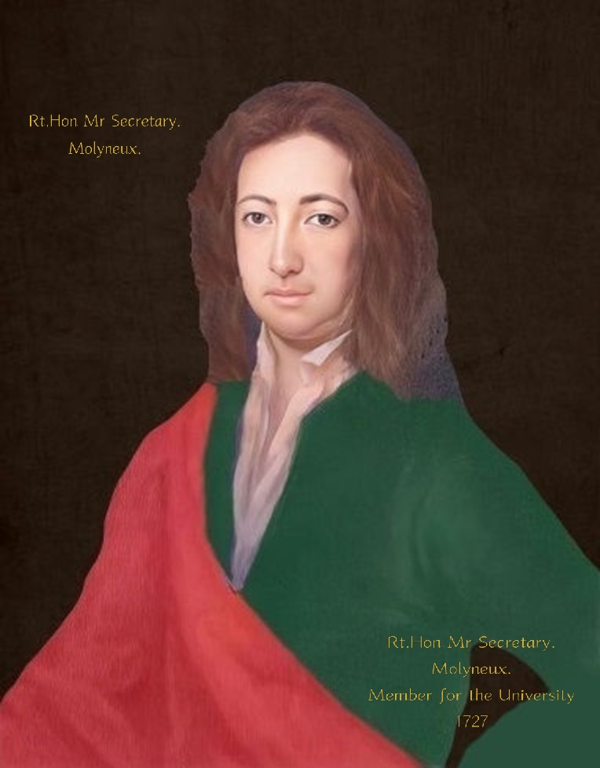
Figure 1. The Right Honourable Samuel Molyneux FRS (1689–1728)
Appointed in 1714 as principal secretary to the Prince of Wales, the appearance of the sitter suggests that it was reinscribed when he became Member of Parliament for Trinity College in 1727, aged 37.
The portrait was shown “in the inventory circa 1914 as paintings belonging to Mrs. Julia Talbot” and was removed from Castle Dillon, Armagh in 1922 by William Arthur Molyneux, a son of the 9th Baronet. It went to his home in Trewyn, Wales. On the 12th May 1981, it was sold by his widow’s executors at auction in Bath to `Pattermore` and believed subsequently resold at auction to the USA.
A portrait of Samuel`s widow Elizabeth, which hung in Castle Dillon, was also bought by Pattermore.

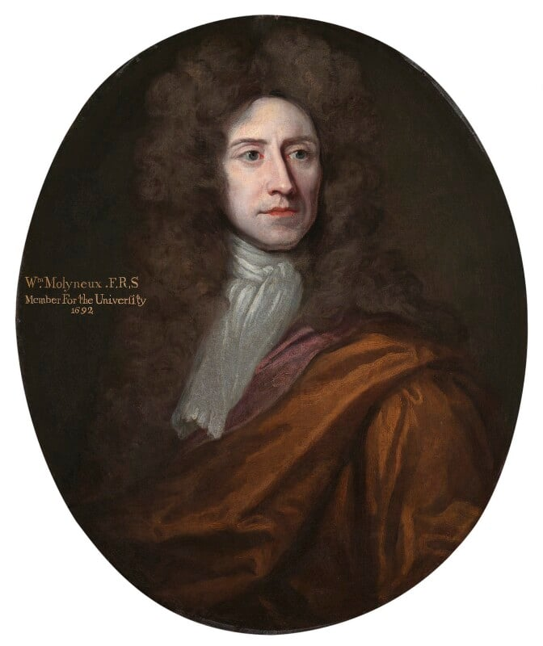
Figure 2. William Molyneux FRS. (1656-1698)
Samuel Molyneux`s father, William Molyneux FRS. was Member of Parliament for Trinity College Dublin in 1692 and from 1695 until his death in 1698. Painted circa 1696, William`s portrait was originally framed as a pair, with an oval portrait of the same size of his good friend John Locke painted by Michael Dahl. They originally hung in Castle Dillon Armagh and were bought at the 12th May 1981 auction in Bath by the National Portrait Gallery.

NPG 5386. Listed as “Unknown artist”. Copyright National Portrait Gallery, London.

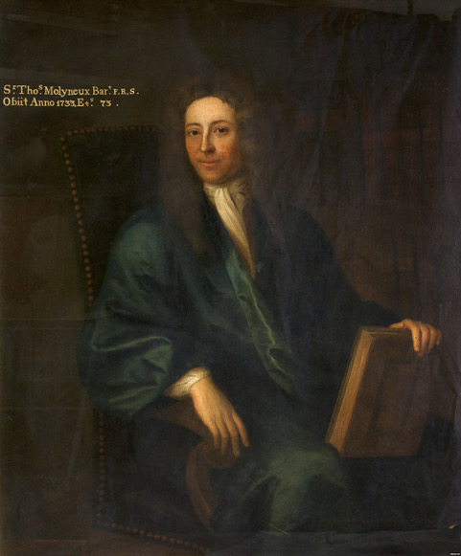

Figure 3. Dr. Sir Thomas Molyneux Bt. FRS. (1661-1733)
Samuel Molyneux`s uncle and guardian. After Samuel Molyneux`s death in 1728, with the agreement of his widow Elizabeth in 1730 Thomas procured by Patent the 1st Baronetcy of Castle Dillon Armagh

The last Molyneux owner of Castle Dillon was William Arthur Molyneux (1877-1928) the son of the ninth Baronet, Rev Sir John Charles Molyneux (1843-1928). Predeceasing his father by a few months, William never held the title. It passed in 1928 to a cousin, Ernest, who became the 10th Baronet. He had no connection with Castle Dillon and died in 1940 without a male heir, leaving the title extinct.

Portrait Copyright. Armagh County Museum collection.

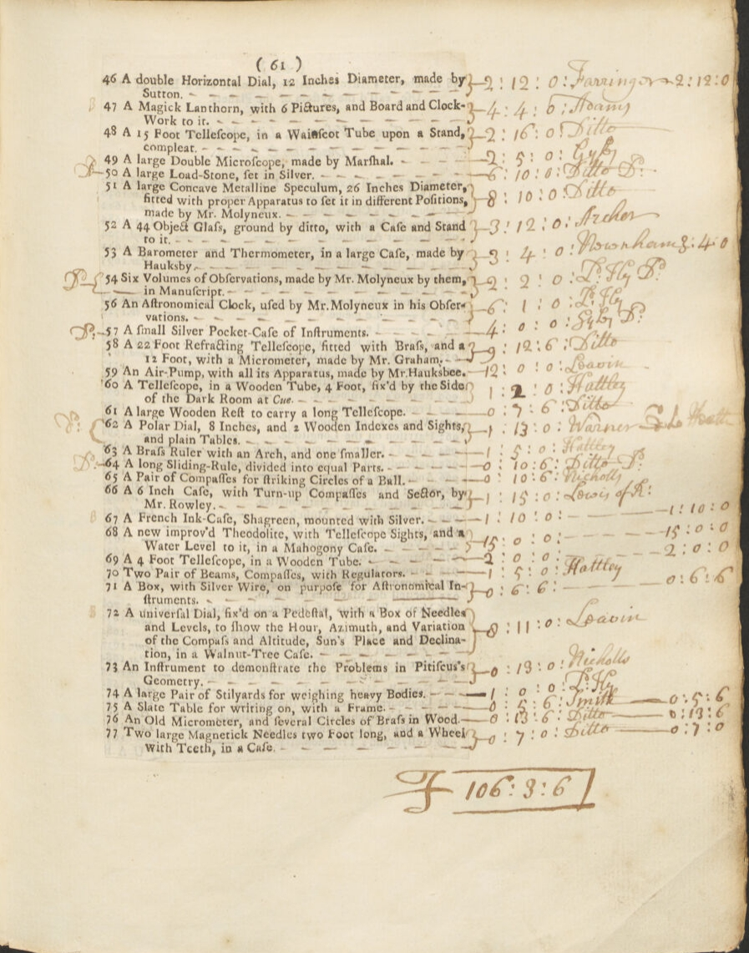

Figure 4. Folio 61. Item 51. “A large Concave Metalline Speculum, 26 Inches Diameter, fitted with proper Apparatus to set it in different Positions, made by Mr. Molyneux".

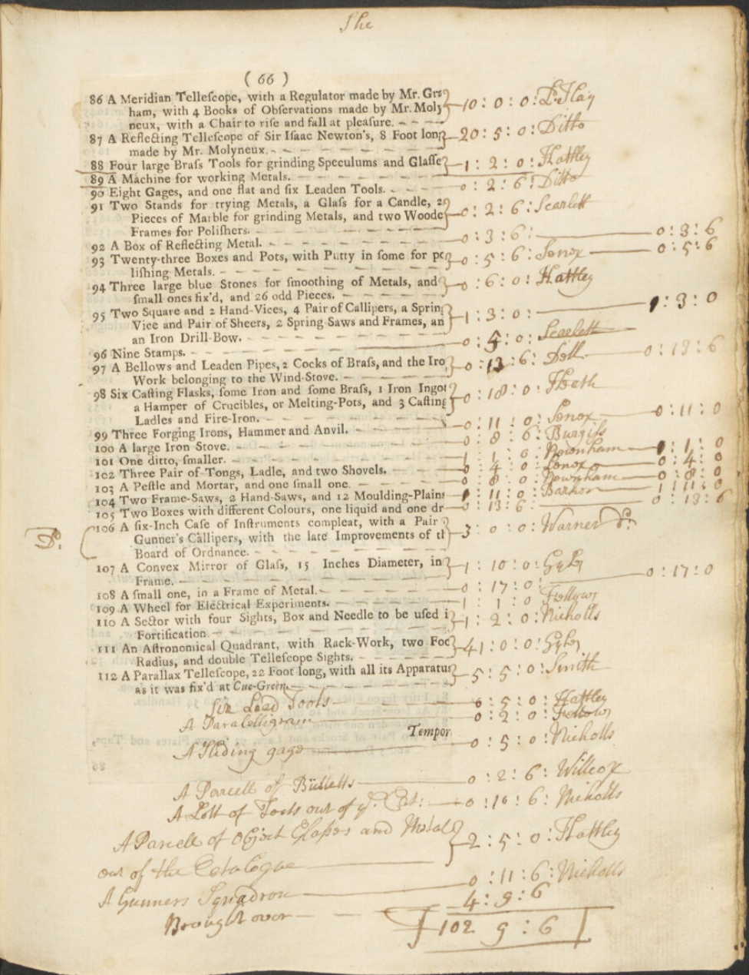

Figure 5. Folio 66. Item 112. Samuel Molyneux`s “A parallax telescope, 22 foot long, with all its apparatus fitted as it was fix`d at Cue-Green”.

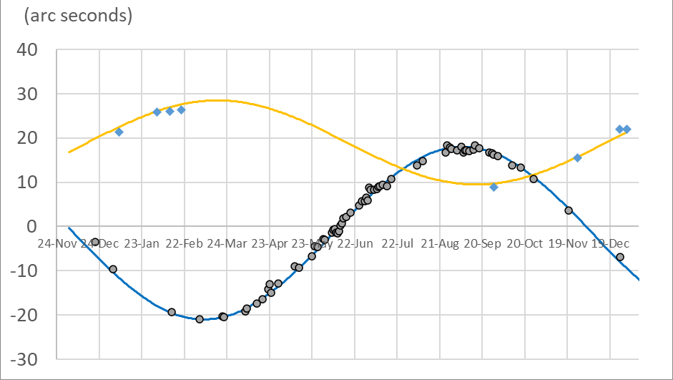
Figure 6. Kew observations for Gamma Draconis and “anti-Draco or Telescopica in Auriga” made between November 1725 and December 1726. Plotted from Samuel Molyneux’s “Observations made at Kew” in “Bradley’s Miscellaneous Works and Correspondence” (1832) Edited by S P Rigaud.
Approximately 90% of these observations were made by Samuel Molyneux.

Blue and yellow lines are sine curves fitted to the data. Blue is Gamma Draconis and yellow is control star “Anti-Draco or Telescopica in Auriga”. The plotted data is courtesy of Paul Quincey.

The faint ~7th magnitude `control star`, “anti-Draco or Telescopica in Auriga”, was only visible during the hours of darkness, preventing zenith observations being made between March and September.
The 2nd magnitude star Gamma Draconis was also telescopically visible in daylight, as evidenced by the much greater number of observations.

The telescopes zenith alignment was first established by ensuring its exact registration with the plumbline. To observe and measure a stars bisected position at meridian transit, the telescope was precisely moved along the meridian by the rotation of the calibrated micrometer screw. “This screw had 42 threads in an inch, and the head thereof being divided into 17 equal parts, each part was equal to one second, on the radius 24 feet 3.15 inch”.

Mounted on the “index” in parallel with the coarse screw, the micrometer screw heads sequentially numbered fiducial marks, “numbered so as that increasing the number unscrewed the screw, and brought the snout northward, and consequently brought the telescope to point more southward, and nearer to the zenith” were interpolated and noted. “The difference between these two numbers will shew the number of seconds by which the star hath moved from the situation it had at the time of fixing the mark…. As to the determining the absolute quantity of the whole variation of the star's place at different times of the year, where different observations might be made on different days, near the two extremes, to verify and correct one another by taking the medium of them all; for this purpose at least, it was hardly possible to err half a second by this instrument”.

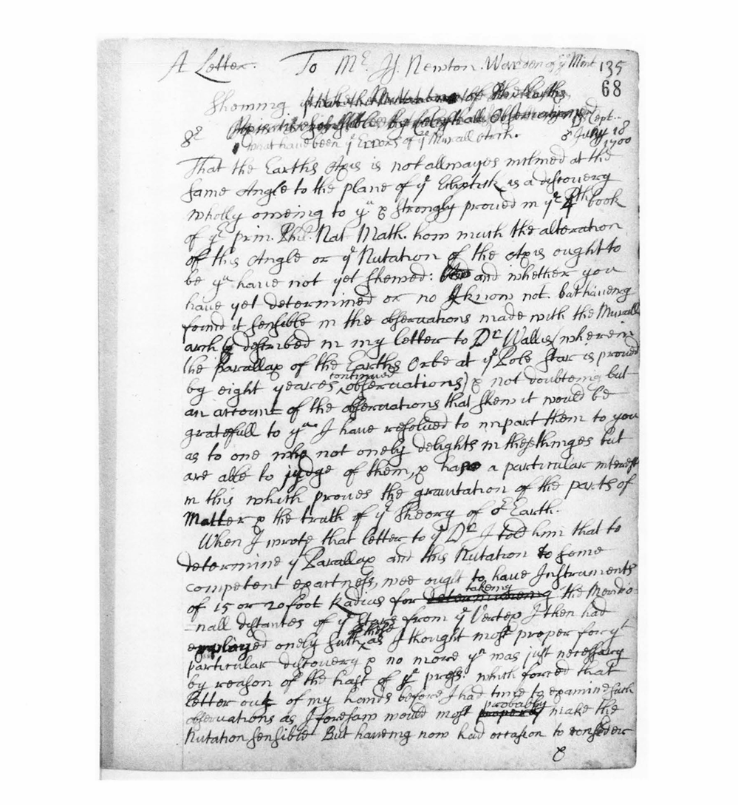
(Letter 820. 18 June 1700. RGO 1/39, f. 68)
Figure 7. First page of Flamsteed`s draft of his letter to Issac Newton; following Flamsteed`s published letter (Letter 772. 20 December 1698) sent to John Wallis regarding the parallax of Polaris. The letter appears to have not been finished or sent. It compares the possible combined positional effects of annual stellar parallax and nutation of the earth`s axis. Flamsteed states, “Had the wall, to which my instrument [Fig13] is fixed, continued stable and unmoved, both the parallax of the orb, with the nutation of the earth's axis, would have been discovered and determined..” Copyright: The Syndics of Cambridge University Library and the Director of the Royal Greenwich Observatory.
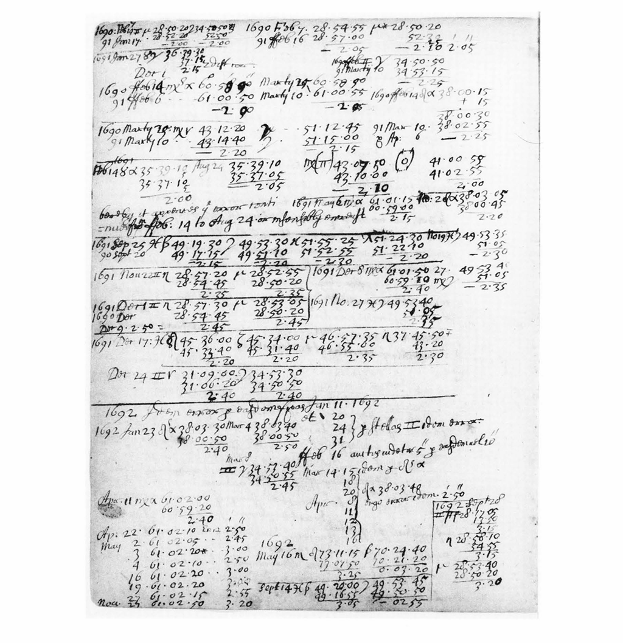
Figure 8. A page of data and calculations, “in the manner common to Flamsteed`s notebooks”. Part of letter 820. (Letter 820. 18 June 1700. RGO 1/39, f. 78 v) Copyright: The Syndics of Cambridge University Library and the Director of the Royal Greenwich Observatory.

Figure 9. `A Compleat system of Opticks`. Cambridge. Smith. 1738. Page 363. Plate 53.
In 1725 Samuel Molyneux gifted this twenty-six-inch-long reflector, “of his creation”, to King John V of Portugal. Presented by the Prince of Wales, it was later given to Francesco Bianchini of Bologna Observatory and afterwards donated by Cardinal Davida to the Institute of Science in Bologna.

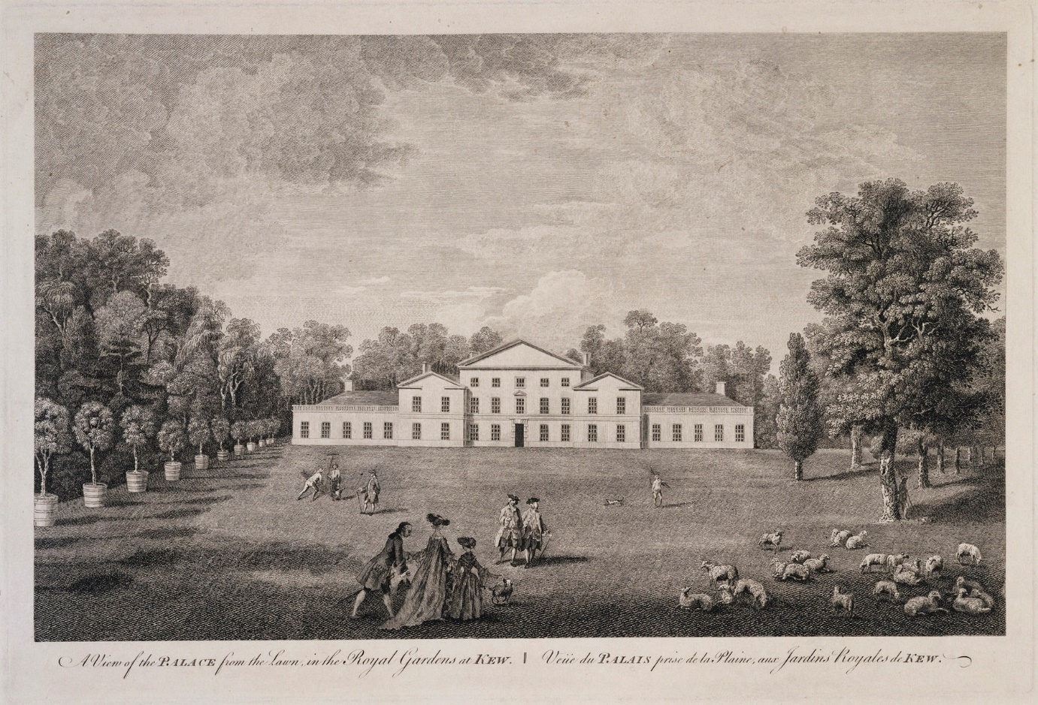
Figure 10. Kew House. The `White House` or Princess Dowager House. Demolished in 1803 on the orders of King George III. Joshua Kirby (1716-1774) Published 1763. Royal Collection Trust.

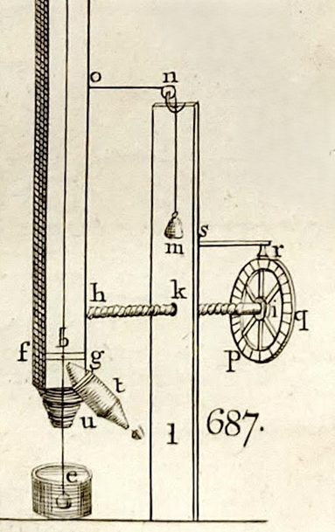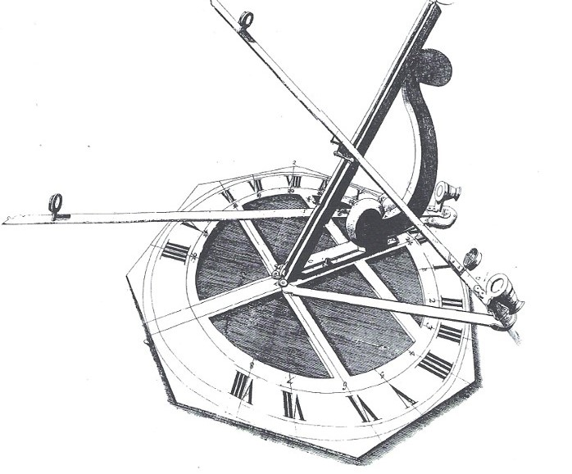
Fig 11. `Parallax instrument`. 1725. Fig 12. `Sciothericum Telescopium`. 1686.

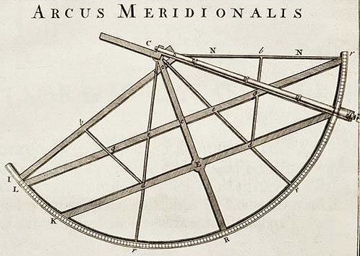
Figure 13. In 1721, Samuel Molyneux had “a mind to purchase the Mural Arc” from Flamsteed`s widow, Margaret. Flamsteed stated that he had “determined the least quantity of the parallax of the orb at the pole-star, that my observations would allow” using this “79 ½ inch” radius Mural Arc. It was constructed for Flamsteed in 1689 by his friend and assistant Abraham Sharp, who he described as “a man much experienced in mechanics and equally skilled in mathematics”. Illustration from Vol 3. Historia Coelestis Britannica.

Dedication.
The author would like to dedicate this paper to his late friend and colleague, Patrick Corvan. Astronomer, Historian and former long serving member of staff of The Armagh Observatory and The Armagh Planetarium.
Acknowledgments.
Professor Mark E. Bailey MBE MRIA MInstP
Emeritus Director of Armagh Observatory.
Dr David Asher. Former Research Fellow. Armagh Observatory.
Dr Rok Nezic. Armagh Observatory and Planetarium.
Dr John Butler. MBE. Emeritus Research Fellow. Armagh Observatory.
Dr Matthew McMahon. Museum Collections Officer. Armagh Observatory.
Dr Yanina Todorova Metodieva. Vienna University Observatory.
Dr Sian Prosser. Librarian and archivist. Royal Astronomical Society.
Carol Conlin. Assistant Keeper. Armagh Robinson Library.
Sean Barden. Curator. Armagh County Museum.
The author.
The author, now retired, is a former member of staff of Armagh Observatory.

References and notes. Where available, primary sources have been used and identified in preference to secondary or tertiary source material.

The list of the Commonwealth Train of Artillery states, “Captain Samuel Molyneux, Master gunner of the field and fire-master”.
a. Robinson Library Armagh. MS. H II. 20. Title, interest and purchase of Castle Dillon. b. `The property was heavily mortgaged to the Caulfields and a young and inexperienced Dillon heir put the estate up for sale in 1664, then known as the Manor of Castle Dillon` J. Kerr. The whole Mannor is so called but the Castle or house of Castle Dillon was built on the North and West side of the great Loch.
Capel Molyneux. `An account of the family and descendants of Sir Thomas Molyneux. Chancellor of the Exchequer in Ireland to Queen Elizabeth. Evesham 1820` William Molyneux. Autobiographical Memoir.1694. p 60.
The distinguished natural philosophers, Rene Descartes (1596-1650) Pierre Gassendi (1592-1655) and Francis Bacon (1561-1626) developer of the `scientific method`.
Ibid. p. 54. Part of testimonial… “Tanquam eximia nativa Indole magneqe Morum probitate verum”.
`Six Metaphysical Meditations wherein it is Proved there is a God And that Man`s Mind is really distinct from his Body….with a short Account of Des-Cartes Life`. London 1680.
a. `The Discourses and Mathematical Demonstrations Relating to Two New Sciences`. Pub. Lodewijk Elzevir. Leiden. 1638. b. Southampton City Archives. MS. D/M 4/16.
William Gascoigne (1612-1644) astronomer and mathematician. English originator of the astronomical micrometer and the telescopic sight. Member of the "North Country" astronomers; including Jeremiah Horrocks, William Crabtree and Richard Towneley. Gascoigne was a follower of Johannes Kepler and in 1639 initiated precision observational astronomy in England.
a. Southampton City Archives. D/M. 1/1, ff. 22-24. b. Battle of Marston Moor, 16th July 1644. c. Flamsteed “procured Mr Gascoigne`s and Crabtree`s papers” from Townley and said that Gascoigne had considered telescopes “in a different manner from that which they had been hitherto treated”.
John Browne. Scientific instrument maker. From 1661, designer of the Triangular Quadrant. `Browne, The Triangular Quadrant…etc` (London. 1662) Born circa 1630`s. Became Master of The Clockmakers` Company London in 1681.
John Yarwell at the Archimedes and Three Golden Prospects, near the great North-Door in S. Paul`s Church-Yard: London.
a. Solar eclipse. Phil Trans. No 164, p 749. b. Lunar eclipse. Phil Trans. No 185, p 236 and “Anno 1681/2 Feb. 11/12. Eclipsis Lunae totalis”. SCA. MS D/M. 1/1, ff. 61-62.
Thomas Molyneux to William Molyneux, 26 May 1683, in Dublin Univ. Mag., 18, 318 (1841).
British Museum. Add. MS. 4811 f 160. Minute Book of the Dublin Philosophical Society.
a. Francis Aston. Secretary of The Royal Society. Aston to Molyneux 26th February 1683/4. TCD. MS 1.4.18. No 34(1). b. “I began to busy myself in forming a society in this city agreeable to the design of the Royal Society in London…and took on us the name of the Dublin Society”.
a. Molyneux`s friend, Dr Edmond Halley FRS. Appointed second Astronomer Royal in 1720. b. Johannes Hevelius FRS. Renowned Polish Astronomer and Mayor of Gdansk.
Molyneux to Aston. British library., Add. MS.4811, f. 174v; Royal soc., Early letters M. 1. 92.
‘The English Atlas of Moses Pitt 1680-83’, in Geog. J., 95, 294-5 (1940).
Letter, Flamsteed to Newton. 26 September 1685. Describing Molyneux`s account of the French instruments, “scarcely half of the radius used by Flamsteed and much less adapted for their purpose”.
a. Letter, Flamsteed to Molyneux. 11 September 1685. SCA. D/M. 1/1. f. 93. b. The Correspondence of John Flamsteed, The First Astronomer Royal, Volume 2. Institute of Physics Publishing. 1997. Letter 541. p. 244.
a. Letter, Flamsteed to Molyneux. 19 January 1685/6. SCA. D/M. 1/1. f. 94. b. The correspondence of John Flamsteed etc. Vol 2. Letter 552. p. 273.
“Juvenis ingeniosus Edmundus Hally, Oxoniensis”. Phil Trans. Vol 10. 1675, p 371.
Letter, Flamsteed to Molyneux. 23 November 1686. The Correspondence of John Flamsteed. Vol 2. Letter 573. p. 309.
a. Royal Society code NA5638. b. The Record of the Royal Society (4th ed. London 1940) p. 485.
a. Sciothericum Telescopium. Dublin. 1686. Chapter VIII. pp 30-33. b. SCA. D/M. 1/1, ff. 95-96. “Sciothericum” is derived from `Skiotherikos`, the ancient Greek word meaning `of a sundial`.
"A Catalogue of the Mathematical Instruments brought into the Library. 29th September 1703”. Item number 20. “Mr Molineux his Telescopick dial”. Manuscript M. 1.17.12. 20. Trinity College Library, Cambridge.
The Dublin Univ, Mag., xviii, 608.
Richard Ryan, Biographia Hibernica: Irish Worthies, Vol. II. (London & Dublin. 1821) pp 433-37.
Molyneux to Flamsteed 17th May 1687; Molyneux to Halley 7th July 1687. Royal Society copy letter-book, ii (1), 103.
In The Authors Preface, Newton stated that he had “endeavoured to subject the phaenomena of nature to the laws of mathematics, I have in this treatise cultivated mathematics so far as it regards philosophy….I heartily beg that what I have here done may be read with candour; and what the defects in a subject so difficult be not so much reprehended as kindly supplied, and investigated by new endeavours of my readers. Issac Newton. Cambridge, Trinity College May 8, 1686”.
“There was a rumour spread upon the landing of the Prince of Orange into England, and the disarming of the protestants in Ireland, that there was to be a general massacre of them on the 9th of December 1688; upon which, some thousands left the City of Dublin, and fled into England. On the very day before the expected stroke, he [William Molyneux] and his family stood with some constancy”. Ibid. An account of the family and descendants of Sir Thomas Molyneux etc. pp. 30-31.
Newton I., `Opticks: Or, a Treatise of the Reflexion, Refraction, Inflexions and Colours of Light`. (Three books in one) London, 1704. Newton comments in the Advertisement published at the front of his Opticks, describing how part of the book “was written at the desire of some Gentlemen of the Royal-Society in the 1675 [i.e. Book II, parts i-iii] and then sent to their Secretary and read at their meetings [in early 1676] and the rest [i.e. Book I] was added about Twelve Years after [i.e.“about” 1687–88] to complete the Theory; except [for Books III and Book II, part iv]…which were since put together out of scattered Papers”. Simpson. JHA. Vol 40. Issue 4. pp 421-466. Ref. 13.
Dioptrica Nova 1692. Admonition To The Reader. 17th April 1690.
Huygens, Oeuvres, xiii, pp 826-34.
Included in list of recipients on verso of flyleaf of William Molyneux`s personal first edition held in The British Museum. Formerly B.L., pressmark 537.K.17.
The University of California, Berkely and the city of Berkeley, California are named after him.
An account of the family and descendants of Sir Thomas Molyneux. Chancellor of the Exchequer in Ireland to Queen Elizabeth. Evesham 1820. William Molyneux. Autobiographical Memoir.1694. p 74.
A Catalogue of the Library of the Honourable Samuel Molyneaux, Deceased: Late Secretary to His Present Majesty when Prince of Wales, and One of the Lords of the Admiralty, Consisting of Many Valuable and Rare Books in Several Languages and Faculties Et Al.
The Royal Society Archives. London. Letter, from William Molyneux to Hans Sloane, dated at Dublin, 04 November 1697, EL/M1/99.
British Museum. Letters to Sir H. Sloane, 1697, 1697/8. MS 4036, f. 367. William Molyneux wrote, “I am apt to think he may not conceive it worth his while, but may rather leave it to others to build on that Foundation that he has laid”.
Correspondence of Sir Isaac Newton and Professor Cotes: including letters of other eminent men. J. Edleston. London. 1850. Preface. pp. xv-xvii.
In 1701, Issac Newton, now Warden of The Royal Mint at the Tower of London, wrote a detailed rebuttal of Molyneux`s book. This was in a memorandum entitled `The Case of the Parliament of Ireland`. It summarised the history of English rule in Ireland since its conquest by Henry II in 1172 and argued that because Ireland is under the Crown “by consequence” it is subject to legislation by the English Parliament. Mint 19/3/456-7. The National Archives.
The Case of Ireland`s Being Bound by Acts of Parliament in England, Stated. Molyneux. 1698. Introduction and occasion of this disquisition. Para 3.
Faulkner`s Dublin Journal, 3-7 October 1749. 1749 Dublin edition, Publishers advertisement.
`Drapier`s Letters` by “M.B. Drapier” [Swift]. 13th October 1724., “To the whole people of Ireland”. Number 4 off 7. Pamphlets printed in Dublin by John Harding.
Founders Online, National Archives. Documents. Franklin/01-17-02-0060.
The writings of Samuel Adams ii (N.Y., 1906) pp 254-264. “We shall esteem the arguments to be so sensible. and it may justly be added so learned, a gentleman as Mr Molyneux, especially as he had the approbation of his friend Mr Locke, to be valid”.
P. Wayman and N.D. McMillan. William Molyneux (1656-1698). Physicists of Ireland: Passion and Precision. Institute of Physics Publishing. Bristol. 2003. p. 22.
In his Epistle Dedicatory of Dioptrica Nova, William Molyneux said of Locke, “to none do we owe, for a greater advancement in this part of philosophy than to the incomparable Mr Locke, who, in his Essay of human understanding, hath rectified more mistakes…than are to be met with in all the volumes of the ancients”.
Molyneux to Locke. 2nd March 1693. In `Some Familiar Letters between Mr Locke and Several of his Friends`. 1708. First edition. Printed for A. and J. Churchill at the Black Swan in Pater-Noster row. London.
Ibid. Molyneux to Locke. 28th March 1693. Locke to Molyneux 18th April 1693.
Ibid. Molyneux to Locke. 12th August 1693. Locke to Molyneux 23rd August 1693.
Ibid. Molyneux to Locke. 12th August 1693.
Ibid. Molyneux to Locke. 7th May 1695.
Ibid. Molyneux to Locke. 7th May 1695.
Ibid. Molyneux to Locke. 24th August 1695.
An Essay Concerning Human Understanding. Locke 1690. Book II Chap IX. Of Perception. Para 8.
Ibid. Molyneux to Locke. 20th September 1698.
“Not long after his return into Ireland he was attacked with a severe fit of the stone, which caused such violent reaching, that he broke a blood vessel in his stomach. This was followed by such excessive loss of blood, that he died after two days illness, October 11, 1698. Upon opening his body, there were found, in his right kidney, several large stones; and in his left several smaller”. An account of the family and descendants of Sir Thomas Molyneux. Chancellor of the Exchequer in Ireland to Queen Elizabeth. Evesham 1820. Page 35.
Ibid. Mr Locke to Dr. Molyneux. 27th October 1698. b. The Dublin Univ, Mag., 18, p. 751 (1841).
Some Familiar Letters between Mr Locke and Several of his Friends. 1708. Printed for A. and J. Churchill. Awnsham Churchill (1658-1728) wealthy Whig politician and publisher. Locke’s close friend, business partner and financial agent. In 1701, he held approximately £1,300 of Locke`s money.
“His son Samuel was but nine years old when he died. He left the care of him and his fortune to his brother, Dr. Thomas Molyneux, and to Samuel Dopping, Esq. his nephew, a worthy son to Dr. Anthony Dopping, Lord Bishop of Meath”. Ibid. An account of the family etc. p. 36.
“He discovered an uncommon turn to letters, from his childhood, and early shewed his father's genius for mathematical studies. He entered the College of Dublin in his sixteenth year, and was placed under the care of Dr. Robert Howard, afterwards Lord Bishop of Elphin”. Ibid. Page 36.
“Arithmetic demonstrated without Euclid or Algebra”.
Berkeley, George. `The Analyst: or A Discourse addressed to an Infidel Mathematician`. Dublin 1723. Title page and Sections XXII, p 10. XXXV, p 18.
`Journey to the North. August 7th 1708` Samuel Molyneux, age 19, accompanied by his cousin, Samuel Dopping, age 37. “Maherlin…Here I stopped to a visit to my old Tutor, Mr. Redman, who lives with his Uncle Cuppaidge, Minister of the Place”.
Extract from `Some Unsolved Problems of Masonic Research` by V.W. Bro. R.E. Parkinson, The Lodge of Research Transactions 1958-1962… “So, here in the Trinity College, Dublin, MS, we have, for the very first time, a document which has separate secrets for three separate degrees: the enterprentice, the fellowcraftsman and the master”. Henry Carr, "Six Hundred years of Craft Ritual".
a. Samuel Molyneux, Armagh, to Thomas Molyneux, Dublin, 14 May 1711, TCD, MS 889, ff 31r-31v. ".. thus, for is certain that many supernaturall appearances did happen to that Mrs Dunbarr and therefore I think ye question should not be of ye reality of ye witchcraft (if we are pleas’d to call it so) but where to place it..". b. The Dublin Intelligence. 14 April 1711. Dublin. “We hear that 8 witches were Try’d at the Assizes of Carrickfergus, for bewitching a young Gentlewoman, were found Guilty, and are to be Imprisoned for a Year and a Day, and 4 times Pillored”.
Bond of Samuel Molyneux to the Treasurer of the Royal Society. MS/390/151. 1 December 1712. `For the payment of fifty-two shillings annually to the Royal Society in four quarterly instalments, as a Fellowship subscription: “I, Samuel Molyneux…do grant and agree...” Sealed and delivered in the presence of Henry Hunt, with two embossed stamps for sixpence each`.
Southampton City Archives., D/M. 1/3. Transcribed letters of Samuel Molyneux. f. 148., f. 154.
SCA. D/M. 1/3., Letter 2, 20th December 1712. f. 33.
SCA. D/M. 1/3., Letter 6, 15th April 1712/3. f.147.
SCA. D/M. 1/3., Letter 2, 20th December 1712. f. 42.
SCA. D/M. 1/3., Letter 2, 20th December 1712. f. 40.
SCA. D/M. 1/3., Letter 2, 20th December 1712. f. 38.
Lives of the Professors of Gresham College. London. John Ward. 1740. p 104.
SCA. D/M. 1/3., Letter 6, 15th April 1713. f. 151.
SCA. D/M. 1/3., Letter 2, 20th December 1712. f. 63.
SCA. D/M. 1/3., Letter 2, 20th December 1712. f. 77.
Archbishop King to Samuel Molyneux. TCD. 750/4/1/123.
SCA. D/M. 1/3., Letter 2, 20th December 1712. f. 77.
SCA. D/M. 1/3., Letter 3, 14th February 1712/3. f. 96.
SCA. D/M. 1/3., Letter 4, 18th February 1712/3. f. 98.
SCA. D/M. 1/3., Letter 4, 18th February 1712/3. f. 99.
An account of the family and descendants of Sir Thomas Molyneux. Chancellor of the Exchequer in Ireland to Queen Elizabeth. Evesham 1820. William Molyneux. Autobiographical Memoir.1694. p.76.
SCA. D/M. 1/3., Letter 4, 18th February 1712/3. f. 101.
“The new Lord Chamberlain knew Flamsteed well; and a hint was given to him that he might….get all the spurious copies of his printed observations into his own hands. He accordingly drew up a memorial and petition to the Lords of the Treasury….whereupon 300 copies of this obnoxious work… were delivered up to him, which he immediately committed to the flames, “That none might remain to show the ingratitude of two of his countrymen, who had used him worse than ever the noble Tycho was used in Denmark”. An account of the Rev John Flamsteed. Baily. 1835. Preface. page xlv.
a. Appendix to Flamsteed history. Francis Baily 1835. No 212. Page 322. b. Reported burnt in late April 1716: “which burned a large fire, fuelled by 13,500 sheets of printed paper”. LHL. Dean. 2025.
SCA. D/M. 1/3., Letter 4, 18th February 1712/3. f. 101/2.
SCA. D/M. 1/3., Letter 4, 18th February 1712/3. f. 102/3.
Letter from Thomas Molyneux to William Molyneux. 17th July 1683.
SCA. D/M. 1/3., Letter 5, 28th February 1713. f. 126-7.
SCA. D/M. 1/3., Letter 5, 28th February 1713. f. 120.
SCA. D/M. 1/3., Letter 5, 28th February 1713. f. 119-120.
SCA. D/M. 1/3., Letter 5, 28th February 1713. f. 131., f. 135.
SCA. D/M. 1/3., Letter 5, 28th February 1713. f. 139.
SCA. D/M. 1/3., Letter 6, 15th April 1713. f. 151.
A Dictionary of the Printers and Booksellers who were at work in England, Scotland and Ireland from 1668 to 1725. (Oxford, 1922) p. 24.
SCA. D/M. 1/3., Letter 5, 28th February 1713. f. 144.
SCA. D/M. 1/3., Letter 5, 28th February 1713. f. 143.
SCA. D/M. 1/3., Letter 5, 28th February 1713. f. 143.
SCA. D/M. 1/3., Letter 6, 15th April 1713. f. 154.
SCA. D/M. 1/3., Letter 7, 20th April 1713. f. 158-9.
Royal Society letter of recommendation. 30th March 1713. CMO/2/237.
Coxe, Life of Marlborough, iii. 360, Wade's edition.
“…a few months before Queen Ann's death, he was sent over on some secret business”. Ibid. An account of the family and descendants of Sir Thomas Molyneux, etc. Page 38.
Correspondence from Antwerp. June 11, 1714., Samuel Molyneux to his cousin, Samuel Madden.
Confirmed by Archbishop King. Dublin. TCD 750/4/1/1494.
In 1715, Samuel Molyneux had William Derham FRS (1657-1735) appointed as Chaplain to the Prince of Wales. Becoming Canon of Windsor in 1716. Treasurer in 1717, Derham dedicated his Philosophical Letters (1718) to Molyneux, from “His Most Obliged Humble Servant, W. Derham”.
Dictionary of National Biography, 1885-1900., Volume 38. Molyneux, Samuel. Agnes. M. Clerke.
John Hadley. “An account of a catadioptik telescope”. Described and illustrated in Phil Trans. xxxii.1722/3. pp. 303-312. “Observations on the satelittes of Jupiter and Saturn made with the same telescope”. Phil Trans. xxxii.1722/3. pp. 385-6.
“A letter from the Rev. Mr. James Pound, rector of Wanstead, to Dr. Jurin, Secr. R. S. concerning observations made with Mr. Hadley's reflecting telescope”. Phil. Trans. xxxii. 1722/3. pp 382-384.
A Compleat system of Opticks. Cambridge. Smith., 1738. Book III. Chapter II. P. 302.
Presented by the Prince of Wales to King John V of Portugal. Given to Francesco Bianchini of Bologna Observatory and later donated by Cardinal Davida to the Institute of Science in Bologna.
In 1726, “the first reflecting telescope seen in France” was presented to Louis XV. “the telescope may plausibly have been another diplomatic gift, constructed by Molyneux and similarly presented in the name of the Prince of Wales”. A. D. C. Simpson. JHA. 2009. Vol 40. Issue 4. pp 421-466. Ref 67.
Philosophiae Naturalis Principia Mathematica. Motte 1729 Book III. Prop XIV. Theor XIV. Cor. 2.
An attempt to prove the Motion of the Earth from observations, made by Robert Hooke Fellow of the Royal Society. London. Printed for J. Martyn at the Bell in St.Pauls Church yard, 1674.
The distances of the Stars. Halley Lecture. C.A. Murray., RGO. 1988. Obs. 108. p 201.
Lives of the Professors of Gresham College. London. John Ward. 1740. p 104.
Thomas Molyneux to William Molyneux, 9 June 1693. in Dublin Univ, Mag., 18, 318-20 (1841).
Flamsteed. From the Latin, “Puteus profunditatis 120. Ped cum tubo pro observ parallaxis terrae”.
On July 30, 1679, Flamsteed wrote, “Ego in puteo subterraneo transitum observavi lucidæ in capite Draconis proprius ad verticem quam Faber viderit Junii 20, cum meridiem media nocte strinxerit”; In an underground well I observed the passage of a star on the head of the Dragon, closer to the zenith, than Faber (?) saw on June 20 at midnight. Flamsteed`s history; Francis Baily 1835. p. lix.
1903. Obs. 26. 138M. “A well of depth 120 feet with a tube to observe the parallax of the earth”.
a. Appendix to Flamsteed`s history. Francis Baily 1835. b. Publications of the Astronomical Society of the Pacific, Vol. 54, No. 321, p. 238.
John Flamsteed. 1712. Office of the Ordnance. “I doo hereby certifye that Joseph Crosthwait has been employed as an Extraordinary Laborer under me from the last day of December last passed…”.
a. Appendix to Flamsteed history. Francis Baily 1835. Letter No 244. Page 343. b. Previously, in February 1713, Samuel Molyneux had used and described Flamsteed`s instruments as “his Mural Quadrant….with another moveable Quadrant in the Camera Stellata is all he has now in order or makes use of”. SCA. D/M. 1/3., Letter 4, 18th February 1712/3. f. 101.
See references 135 and 137.
Appendix to Flamsteed history. Francis Baily 1835. No 250. Page 346.
Jeremiah Horrocks (1618-1641) First English person to show that the Moon moves around the Earth in an elliptical orbit. He predicted and observed the transit of Venus of 1639, enabling him to estimate the size of Venus and the distance of the Earth from the Sun. Horrock`s report, `Venus in sole visa` [Venus seen on the Sun] was published in 1662 by the Polish astronomer Johannes Hevelius.
Philosophical Transactions. No 202. pp. 844-849.
An account of the family and descendants of Sir Thomas Molyneux. Chancellor of the Exchequer in Ireland to Queen Elizabeth. Evesham 1820. p 75. para 2.
a. Flamsteed`s published letter on the parallax of the pole star. 20 December 1698. The correspondence of John Flamsteed. The First Astronomer Royal. Vol 2. Letter 772 (774) p. 708: b. A missing manuscript, from the Latin translation published in John Wallis, `Opera mathematica`, 3 vols (Oxford. 1693-9) Vol. 3 (1699) pp. 701–08.
In a preface to the Hist. de L`Acad. des Sciences, 1699 and later “in Fontenelle`s history of the Academie des Sciences”.
Jacques Cassini FRS. (1677-1756) French Astronomer. Head of The Paris Observatory from 1712. Ole Roemer (1644-1710) Danish Astronomer, Paris Observatory. In 1666 to 1676 Roemer and Jacques Cassini`s father, Jean Dominique Cassini (1625-1712), demonstrated that light travels at a finite speed. Published in Le Journal des Scavans. 1676. pp. 233-236.
a. `A Letter to Mr. Is. Newton, Warden of the Mint, showing what have been the errors of the Mural Arc`. An unfinished and reported unsent letter from Flamsteed to Newton. Began June 18. 1700. RGO 1/39, f. 68. b. The correspondence of John Flamsteed. Vol 2. Letter 820. p. 829. c. Appendix to Flamsteed`s history. Francis Baily. 1835. No 52. pp. 176-179.
Newton had stated…“the pole of the Earth....moves in a slightly wavy curve, the mean distance of which from the pole of the ecliptic remains constant”.
See `An analysis of the errors in John Flamsteed`s Mural Arc observations`. William Blitzstein. University of Pennsylvania. Vistas in Astronomy Vol. 41, No. 1, pp. 139-155, 1997.
See also `Reflections on Monsieur Cassini 's remarks on my Letter to Dr Wallis`. Sent to Sir Christopher Wren in 1702. The correspondence of John Flamsteed etc. Vol 2. Letter 880. p. 974.
At the Paris Observatory in 1706, Jacques Maraldi, cousin of Jacques Cassini, had also observed unusual small seasonal advancements and retardations in the meridian transit timings (right ascension) of Sirius and Arcturus.
Philosophical Transactions. Vol XXXI. pp. 1-5.
Miscellaneous Works and Correspondence of The Rev James Bradley. Rigaud 1832. A Description of an Instrument set up at Kew, in Surrey, for investigating the annual Parallax of the Fixed Stars, with an Account of the Observations made therewith. By Samuel Molyneux. p. 93 (Obs book K.14)
Gentleman`s Magazine, XXI, 1751. pp. 523-524.
Ibid. Miscellaneous Works and Correspondence… p. 98.
Ibid. Miscellaneous Works and Correspondence… p. 93-94.
Ibid. Miscellaneous Works and Correspondence… p. 93.
Ibid. Miscellaneous Works and Correspondence… p. 97-98.
Ibid. Miscellaneous Works and Correspondence… p. 98.
Ibid. Miscellaneous Works and Correspondence… p. 100.
Ibid. Miscellaneous Works and Correspondence… p. 102.
Ibid. Miscellaneous Works and Correspondence… p. 110.
Bailey et al. Buildings and Location of Armagh Observatory. Irish Geog Vol 54. 2. p116 &132-4.
Ibid. Miscellaneous Works and Correspondence… p. 93.
“Considering this day the observation of yesterday [December 17th 1725] where the star Caput Draconis seemed even at the entrance to be to the right hand, or on the south side of the thread, consequently, that when it was near the cross, it must have been some two or three seconds south thereof, and this being a deviation directly contrary to that of the annual parallax of the earth, it was at first mistrusted that the mark had not been so truly fixed as it should have been; but subsequent observations proved the contrary; and it was afterwards concluded that the mark and star did nearly agree when first fixed, and this alteration was a real alteration in the apparent place of the star, as will be seen hereafter” Samuel Molyneux. Ibid. Miscellaneous Works and Correspondence. p112-13.
Ibid. Miscellaneous Works and Correspondence… p. 137
a. Isaac Newton The Last Sorcerer. 1997. Michael White. Chapter 14. Page 357, regarding the burning of Newtons papers in 1727…“unlike devotees such as Halley or Stukeley, Conduit knew no science”. b. Kings College Library, Keynes MS 130. 7, sheet 2.
a. Latin, nutatio, nodding or swaying. b. Explanatory Supplement to The Astronomical Almanac. 1992. Definition, page 732. Explanation and types of nutation, pp. 109, 111-121. 132-3. 199-201.
Conduitt, John, Memorabilia, King’s College Library, Keynes MS. 130. 5. Miscellanea No 2. 6r.
Ibid. Miscellaneous Works and Correspondence… pp. 114 & 134.
Ibid. Miscellaneous Works and Correspondence… p. 147.
“…whose longest diameter will be in the direction wherein the earth is then moving in its orbit, and the earth will be nearest to the advancing end of this spheroid….immediate consequence will be that all objects seen in the zenith….will suffer a small refraction, the rays….being bent in the upper regions of the atmosphere always towards the following end of the spheroid….the long diameter of this spheroid lies in the plane of the ecliptic, and being always a tangent to that part of the earth's orbit where it then is, it will in the space of a year make one whole revolution”. Molyneux. Miscellaneous Works and Correspondence. Chapter II. xx-xxi.
Ibid. Miscellaneous Works and Correspondence. Chapter II. xxi and xxii.
Conduitt, John, Memorabilia, King’s College Library, Keynes MS. 130. 5. Miscellanea (assorted notes and anecdotes concerning Newton) No 2, 6r.
Ibid. Miscellaneous Works and Correspondence. Chapter II. xx.
An experiment or set of observations which is held to be in some sense decisive in confirming or falsifying a theoretical explanation of a phenomenon.
Ibid. Miscellaneous Works and Correspondence. Chapter II. xx.
Philosophical Transactions, No 406. vol XXXV. p. 641.
Ibid. Miscellaneous Works and Correspondence. Chapter II. xix.
a. Explanatory Supplement to The Astronomical Almanac. 1992. Definition, page 732. Explanation and types of nutation, pp. 109, 111-121. 132-3. 199-201. b. Determination of the Constants of the Diurnal Nutation. Science. 8 Nov 1895. Vol 2. Issue 45. pp. 613-617; Evidence for a Nearly Diurnal Term in the Nutation of the Earth's Axis. Nature 201, 481; Parameters of the Earth’s Free Core Nutation from Diurnal Strain Tides. Sci Rep 10, 9756.
“1726, Wednesday morning, September 28. Mr. Bradley rose before day, to observe the Telescopica in Auriga, observed the last time the 20th of February last, quod vide”. Miscellaneous Works and Correspondence. Page 180.
Celestial latitude. `Angular distance…. measured north or south of the ecliptic along the great circle passing through the poles of the ecliptic and the celestial object`. Explanatory Supplement to The Astronomical Almanac. 1992. Definition., p. 730.
Ibid. Miscellaneous Works and Correspondence. Chapter II. xxii.
SCA. D/M. 1/3. Letter 6, 15th April 1713. f. 147.
Archbishop King to Samuel Molyneux. 1712-13. TCD. 750/4/1/74., TCD. 750/4/1/121.
“…when the difference happened between the King and his son, he [Samuel Molyneux] acted with so much prudence and moderation, that he was in no sort obnoxious to his Majesty”. An account of the family and descendants of Sir Thomas Molyneux. Chancellor of the Exchequer in Ireland to Queen Elizabeth. Evesham 1820. Page 38.
“Mr Newton coming to see me Sept. 4, 1694, and discoursing of the theory of the moon, to let him see what I had done in order to restore her motion, I produced and shewed him these 3 sheets {or synopses} of her observed and calculated places compared”. Francis Bailey. 1835. No 53. p. 191.
“I desire only such observations as tend to perfecting the theory of the planets, in order to a second edition of my book”. Newton to Flamsteed. 1st November 1694. Francis Bailey. 1835. No 19. p. 138.
Appendix to Flamsteed`s History. Francis Baily. 1835. No 43. Page 166. Jan. 6, 1698-9.
Scottish astronomer and mathematician, David Gregory (1659-1708) Corresponding acquaintance of Isaac Newton, supporting him in his dispute with Leibniz. In 1691 in preference to Flamsteed, Newton recommended Gregory for the Savilian professorship of geometry at Oxford, stating that he “is respected the greatest Mathematician in Scotland”. In 1702 in a letter to his friend John Caswell, Flamsteed called Gregory, “a closet astronomer; and having never thought of throwing away money on instruments, he had rather do his business by a party, on supposals, than observations”.
Published in English in 1715 as The Elements of Physical and Geometrical Astronomy.
SCA. D/M. 1/1, ff. 58-59. “I have an Only Brother.…as he Passes through England, he will presume to wait on you at the Observatory with my humble service, I know your Humanity is such you will not think his Visit is troublesome, but as your leasure permitts you will show him the Raritys of your Caelestiall Habitation, Or recommend him to the Care of your servant Assistant”.
Thomas Molyneux to William Molyneux, 9 June 1683. in Dublin Univ, Mag., 18, 318-20 (1841).
Ibid. Miscellaneous Works and Correspondence. p.182-3.
Philosophical Transactions, No 406. vol XXXV. p. 637.
“So many circumstances, therefore, combine in this one position, that there can be no hesitation in fixing Bradley's station on the eastern side of the clock-house, and on the north of the dwelling in the western part of Mrs. Rushout's stables”. According to Rigaud, 1832. Memoirs of Bradley Ch III xxvi.
Philosophical Transactions, No 406. vol XXXV. pp. 639 & 643.
In 1730, John Harrison designed a “Sea clock” intended for the 1714 English `Longitude prize`. He presented his ideas to Edmond Halley who referred him to George Graham. Graham financed Harrison to build a model of the Sea clock. Taking five years to build, Harrison demonstrated his first Sea Clock (H1) to members of the Royal Society and to the `Board of Longitude` in 1735/6.
Ibid. Miscellaneous Works and Correspondence. p. 198.
Philosophical Transactions, No 406. vol XXXV. pp. 642 & 643.
Ibid. Miscellaneous Works and Correspondence. p. 191.
`A Compleat system of Opticks`. Cambridge. Smith., 1738. Book III. Chapter 1. p. 281. Plumian Professor of Astronomy from 1716 to 1760. After publication, Smith became known as “Old Focus”.
Philosophical Transactions, No 406. vol XXXV. p. 637.
Ibid. p. 637.
Ibid. Miscellaneous Works and Correspondence. p. 287.
Jean Picard (1620-1682) "Uranibourg voyage or astronomical observations made in Denmark”. In Memoires de l`Academie Royale Des Sciences. Tome VII. pp. 193-230. Picard concluded that the variation in the position of Polaris wasn't due to refraction by the atmosphere but stated, “I still couldn`t imagine anything that would satisfy me regarding the variations in the position of Polaris”.
Initiated by his series of measurements of Polaris and other stars, in 1719 Bolognese mathematician and astronomer Eustachio Manfredi FRS (1674-1739) wrote a treatise entitled `De annuis inerrantium stellarum aberrationibus`; `On the Annual Aberrations of Wandering Stars`. Published in 1729, it also assessed the previous determinations regarding annual stellar parallax made by others, including Flamsteed`s measurements of Polaris. In Caput VIII. 150. Pagina 64. Manfredi wrote, “Therefore, it seems that another cause of the errors [“Aberration”] in this Star must be sought than the annual revolution of the Earth around the Sun”.
Ibid. Miscellaneous Works and Correspondence. p.160. Observations at Kew. (Before 22nd April 1726. Observation book K14.)
Philosophiae Naturalis Principia Mathematica. Motte 1729. Book III. Prop XIV. Theor XIV. Cor 2.
Philosophical Transactions, No 406. vol XXXV. p. 660.
a. Manfredi also published a paper, `Concerning Mr Bradley's theory about fixed stars`, read at the Royal Society in 1729, in which he was unable to accept Bradley`s determination of the earths orbital motion around the Sun. Manfredi had been head of the Jesuit College in Bologna, ruled by the Papacy, and remained a believer in the Ptolemaic geocentric model of the Universe. b. See also `De annuis inerrantium stellarum aberrationibus`; `On the Annual Aberrations of Wandering Stars`.
Ibid. Miscellaneous Works and Correspondence. p. 287.
“A Demonstration Concerning the Motion of Light, Communicated from Paris, in the Journal des Scavans, and Here Made English”. Philosophical Transactions, Volume XII (1677).
Philosophical Transactions, No 406. vol XXXV. p. 643.
Philosophical Transactions, No 406. vol XXXV. p. 654.
Matthew Wymondesolde, wealthy brother of Elizabeth Pound; the widow of Rev. James Pound, Bradley`s uncle and former mentor. “By the Favour of my very kind and worthy Friend Matthew Wymondefold Esq, my Instrument has remained, where it was first erected”. Bradley., `A letter etc`.
A Letter to the Right honourable George Earl of Macclesfield concerning an apparent Motion observed in some of the fixed Stars. Read at a meeting of The Royal Society, February 14. 1747.
Ibid, Miscellaneous Works and Correspondence. 27th October 1737. Maupertuis. p. 409.
Histoire de l`astronomie au dix-huitième siècle. Paris. 1827. Preface. p. vii.
Histoire de l`astronomie au dix-huitième siècle. Paris. 1827. p. 420.
a. Airy, G.B., 1872: History and Description of the Water Telescope of the Royal Observatory. Greenwich Observations 1871. p. cxix. b. “Observations were made [of Gamma Draconis] only at the times when aberration produces its greatest effect in north-polar-distance”. p. xxvii.
History Genealogical and Biographical of the Molyneux families (New York 1904) pp 145-146.
An account of the family and descendants of Sir Thomas Molyneux. Chancellor of the Exchequer in Ireland to Queen Elizabeth. Evesham 1820. p 39.
“He was cut off in the flower of his age and fortune….was much beloved by all who knew him. In a word, he had all the good qualities of his father and grandfather; but it pleased God to cut him off before he had measured even his father's short course”. Ibid. `An account of the family`. pp 39-40.
The Daily Journal: Printed for T. Bickerton London. Issue 2269. 29th April 1728.
A Letter From the Reverend Mr. Madden to the Hon. Lady Molyneux, on Occasion of the death of the Rt Hon. Samuel Molyneux, Esq, who was attended by M. St. Andre., a French Surgeon. (Dublin 1730).
The Gentleman`s Magazine.1781, pp. 320-1.
King’s College Library, Keynes MS 129A, pp. 20-21.
The Gentleman's Magazine. Poetry competition, “in celebration and to praise the Queen”.
Dictionary of National Biography. Vol 50. djvu/131. p 119.
a. Sir Richard Manningham. `An Exact Diary of what was observ`d during a close attendance upon M. Toft, the pretended Rabbet-Breeder` (London. 1726) b. Mr St Andre, A Short Narrative of an extraordinary Delivery of Rabbets perform’d by Mr John Howard (London. 1726).
a. Dictionary of National Biography. Vol 50. djvu/131. p 120. b. The Gentleman`s Magazine, July 1781.
a. History Genealogical and Biographical of the Molyneux families (New York 1904) p.146. b. “For those principles which were derived to him from his ancestors, and so carefully inculcated by his father, were so strongly fixed in him, that all the temptations and corruptions of a court, could not shake them”. `An account of the family, etc`. Evesham 1820. p 39.
A Compleat system of Opticks. Cambridge. Smith., 1738. Book III. Chapter 1. p. 281.
Southampton City Archives., D/M. 3/1. (7th January 1716).
The instrument cost “two guineas and a half ”. It could be purchased from “the Inventor at his Office for Insuring Ships &c. in Castle Alley facing the West Entrance of the Royal Exchange”. See also “Caleb Smith. A new method of improving and perfecting catadioptrical telescopes”. Phil Trans xli. 1740. pp 326-40.
Appendix to Flamsteed history. Francis Baily 1835. No 279. p. 362. August 8th, 1728.
Memoirs of John Michell. 1918. Sir Archibald Geikie. Section III. pp 15-16.
Dioptrica Nova. A Treatise of Dioptricks in Two Parts 1692. Chapter 4. pp 224-225.
Memoirs and Correspondence of Caroline Herschel. London. (John Murray). Chapter 2.
Original reference, SC4/2/395.
MNRAS. 1840. Vol 5. p. 23. Dr Stephen Rigaud obituary.
Ibid. Miscellaneous Works and Correspondence. p. 98.
Ibid. Miscellaneous Works and Correspondence. p. 104.
Samuel Molyneux. `Molyneux`s Instruments. Observations made at Kew. 1725`. Ibid. Miscellaneous Works and Correspondence. pp. 114-117.

